**VIVEKANAND EDUCATION SOCIETY’S INSTITUTE OF TECHNOLOGY**

**An Autonomous Institute Affiliated to University of Mumbai**

**Department of Computer Engineering**



Project Report on

Agati: A Personalised Women’s Safety and

Empowerment App

In partial fulfillment of the Fourth Year, Bachelor of Engineering (B.E.) Degree in Computer Engineering at the University of Mumbai Academic Year 2024-25

**Submitted by**

Dhruv Aswani (D17B , Roll no - 01)

Praful Pradhan (D17B , Roll no - 40)

Aman Sande (D17B , Roll no - 46)

Rajveer Tolani (D17B , Roll no - 57)

**Project Mentor**

Prof. Pallavi Saindane

(2024-25)

**VIVEKANAND EDUCATION SOCIETY’S INSTITUTE OF TECHNOLOGY**

**An Autonomous Institute Affiliated to University of Mumbai**

**Department of Computer Engineering**



**Certificate**

This is to certify that ***Dhruv Aswani(01), Praful Pradhan(40), Aman Sande(46) and Rajveer Tolani(57)*** of Fourth Year Computer Engineering studying under the University of Mumbai have satisfactorily completed the project on “***Agati: A Personalised Women’s Safety and Empowerment App***” as a part of their coursework of PROJECT-II for Semester-VIII under the guidance of their mentor ***Mrs. Pallavi Saindane*** in the year 2024-25 .

This thesis/dissertation/project report entitled ***Agati: A Personalised Women’s Safety and Empowerment App*** by ***Dhruv Aswani(01), Praful Pradhan(40), Aman Sande(46) and Rajveer Tolani(57)*** is approved for the degree of Bachelors of Engineering.

| Programme Outcomes | Grade |
| --- | --- |
| PO1,PO2,PO3,PO4,PO5,PO6,PO7,  PO8, PO9, PO10, PO11, PO12  PSO1, PSO2 |  |

Date:

Project Guide:

------------------------------------------

**Project Report Approval**

**For**

**B. E (Computer Engineering)**

This thesis/dissertation/project report entitled ***Agati: A Personalised Women’s Safety and Empowerment App*** by ***Dhruv Aswani(01), Praful Pradhan(40), Aman Sande(46) and Rajveer Tolani(57)*** is approved for the degree of Bachelors of Engineering.

Internal Examiner

---------------------------------------------

External Examiner

---------------------------------------------

Head of the Department

-----------------------------------------------

Principal

-----------------------------------------------

Date:

Place:

**Declaration**

We declare that this written submission represents our ideas in our own words and where others' ideas or words have been included, we have adequately cited and referenced the original sources. We also declare that we have adhered to all principles of academic honesty and integrity and have not misrepresented or fabricated or falsified any idea/data/fact/source in our submission. We understand that any violation of the above will be cause for disciplinary action by the Institute and can also evoke penal action from the sources which have thus not been properly cited or from whom proper permission has not been taken when needed.

| -----------------------------------------  (Signature)  -----------------------------------------  Dhruv Aswani(01) | -----------------------------------------  (Signature)  -----------------------------------------  Praful Pradhan(40) |
| --- | --- |
| -----------------------------------------  (Signature)  -----------------------------------------  Aman Sande(46) | -----------------------------------------  (Signature)  -----------------------------------------  Rajveer Tolani(57) |

Date:

**ACKNOWLEDGEMENT**

We are thankful to our college Vivekanand Education Society’s Institute of Technology for considering our project and extending help at all stages needed during our work of collecting information regarding the project.

It gives us immense pleasure to express our deep and sincere gratitude to Assistant Professor **Prof. Pallavi Saindane** for her kind help and valuable advice during the development of project synopsis and for her guidance and suggestions.

We are deeply indebted to Head of the Computer Department **Dr.(Mrs.) Nupur Giri** and our Principal **Dr. (Mrs.) J.M. Nair ,** for giving us this valuable opportunity to do this project.

We express our hearty thanks to them for their assistance without which it would have been difficult in finishing this project synopsis and project review successfully.

We convey our deep sense of gratitude to all teaching and non-teaching staff for their constant encouragement, support and selfless help throughout the project work. It is a great pleasure to acknowledge the help and suggestion, which we received from the Department of Computer Engineering.

We wish to express our profound thanks to all those who helped us in gathering information about the project. Our families too have provided moral support and encouragement several times.

**Computer Engineering Department**

**COURSE OUTCOMES FOR B.E PROJECT**

Learners will be to,

| **Course Outcome** | **Description of the Course Outcome** |
| --- | --- |
| CO 1 | Able to apply the relevant engineering concepts, knowledge and skills towards the project. |
| CO2 | Able to identify, formulate and interpret the various relevant research papers and to determine the problem. |
| CO 3 | Able to apply the engineering concepts towards designing solutions for the problem. |
| CO 4 | Able to interpret the data and datasets to be utilized. |
| CO 5 | Able to create, select and apply appropriate technologies, techniques, resources and tools for the project. |
| CO 6 | Able to apply ethical, professional policies and principles towards societal, environmental, safety and cultural benefit. |
| CO 7 | Able to function effectively as an individual, and as a member of a team, allocating roles with clear lines of responsibility and accountability. |
| CO 8 | Able to write effective reports, design documents and make effective presentations. |
| CO 9 | Able to apply engineering and management principles to the project as a team member. |
| CO 10 | Able to apply the project domain knowledge to sharpen one’s competency. |
| CO 11 | Able to develop a professional, presentational, balanced and structured approach towards project development. |
| CO 12 | Able to adopt skills, languages, environment and platforms for creating innovative solutions for the project. |

**Index**

**Title Page no.**

**List of Figures 9**

**List of Tables 10**

**Abstract 11**

**Chapter 1: Introduction 12-15**

1.1 Introduction 12

1.2 Motivation 12

1.3 Problem Definition 13

1.4 Existing Systems 13-14

1.5 Lacuna of the existing systems 15

1.6 Relevance of the Project 15-16

**Chapter 2: Literature Survey** **17-20**

A. Brief Overview of Literature Survey 17

B. Related Works 17-20

2.1 Research Papers Referred 17-19

a. Abstract of the research paper

b. Inference drawn

2.2. Inference drawn 19-20

2.3 Comparison with the existing system 19

**Chapter 3: Requirement Gathering for the Proposed System 21-23**

3.1 Introduction to requirement gathering 21

3.2 Functional Requirements 21-22

3.3 Non-Functional Requirements 22

3.4.Hardware, Software , Technology and tools utilized 22

3.5 Constraints 22-23

**Chapter** 4**: Proposed Design 24-26**

4.1 Block diagram of the system 24

4.2 Modular design of the system 25

4.3 Detailed Design 25-26

4.4 Project Scheduling & Tracking using Timeline / Gantt Chart 26

**Chapter 5: Implementation of the Proposed System 27-30**

5.1. Methodology employed for development 27-29

5.2 Algorithms and flowcharts for the respective modules developed 29-30

5.3 Datasets source and utilization 30

**Chapter 6: Testing of the Proposed System 31-37**

6.1 . Introduction to testing 31

6.2. Types of tests Considered 32-33

6.3 Various test case scenarios considered 33-36

6.4. Inference drawn from the test cases 36-37

**Chapter 7: Results and Discussion 38-44**

7.1. Screenshots of User Interface (UI) for the respective module 38-39

7.2. Performance Evaluation measures 39-41

7.3. Input Parameters / Features considered 42

7.4. Graphical and statistical output 43

7.5. Comparison of results with existing systems 43-44

7.6. Inference drawn 44

**Chapter 8: Conclusion 45**

8.1 Limitations 45

8.2 Conclusion 45

8.3 Future Scope 45

**References 46-48**

**Paper Details 49-59**

1. Manuscript of the paper 49-57
2. Acceptance Letter 58
3. Plagiarism report 58
4. Project review sheet 59

**List of Figures**

| **Figure Number** | **Description** |
| --- | --- |
| Fig. 1 | Block Diagram of System for Safety Module |
| Fig. 2 | Block Diagram of System for Inclusivity Module |
| Fig. 3 | Modular Diagram of the System |
| Fig. 4 | DFD Level 0 |
| Fig. 5 | DFD Level 1 |
| Fig. 6 | Project Scheduling Gantt Chart |
| Fig. 7 | Login Page |
| Fig. 8 | Account Creation |
| Fig. 9 | Home Page |
| Fig. 10 | Safety Features |
| Fig. 11 | Events Page |
| Fig. 12 | Registration Page |
| Fig. 13 | Discussion Forum |
| Fig. 14 | Question Page |
| Fig. 15 | Hosting Event |
| Fig. 16 | Video Conferencing |

**List of Tables**

| **Table Number** | **Description** |
| --- | --- |
| Table 1 | Comparison of Existing Women’s Safety Solutions |
| Table 2 | Comparison with Existing Systems |
| Table 3 | Startup Timing Metrics |
| Table 4 | Battery Performance Metrics |
| Table 5 | Scroll and Frame Timing Metrics |
| Table 6 | Comparison of Results with Existing System |

**Abstract**

In an era marked by technological innovation and social progress, empowering women in rural areas stands as an essential and compelling mission. Agati is a transformative digital platform designed to address multifaceted challenges faced by women in rural communities. This application emerges as a beacon of hope and progress, aiming to elevate women's lives in rural areas by fostering both safety and entrepreneurship.

The app's primary objectives encompass enhancing women's safety, promoting financial independence, and nurturing a supportive community. It offers a comprehensive suite of features, including safety tools for immediate assistance, webinars/seminars to build skills, and entrepreneurial support for economic empowerment. Moreover, it fosters a sense of community where women can connect, share experiences, and inspire one another to chase their dreams.

With data-driven insights and local partnerships, proposed system - Women's Safety and Entrepreneurship Application ensures that it aligns with the unique needs and cultural contexts of each community it serves. Its sustainability plan secures its long-term impact and fosters lasting improvements in women's lives. This application represents a catalyst for change, a digital ally in the journey towards gender equality and inclusive development. Through it, women in rural areas can shed limitations, break barriers, and become the architects of their destinies. It's not just an app; it's a movement.

**Chapter 1: Introduction**

**1.1 Introduction**

Agati – A Personalized Women’s Safety and Empowerment App is an innovative mobile application developed with the aim of addressing key challenges faced by women in terms of safety, awareness, and empowerment. In an era where digital solutions are becoming essential for everyday life, Agati offers a reliable platform tailored specifically to support and uplift women.

The app focuses on creating a personalized and secure environment where users can feel protected while also having access to features that promote learning, growth, and interaction. By combining safety tools with empowerment modules, Agati serves as a holistic digital companion for women, encouraging independence and community engagement. With a user-friendly interface and thoughtfully integrated features, the app strives to make a meaningful impact on the lives of its users, helping them feel safer, more informed, and more connected.

**1.2 Motivation**

The motivation behind developing **Agati – A Personalized Women’s Safety and Empowerment App** stems from the growing concerns surrounding women's safety and the lack of accessible platforms for their personal and professional growth. In many parts of the world, especially in developing regions, women often face challenges related to security, lack of awareness about opportunities, and limited access to supportive communities.

We observed that while there are apps focused solely on safety or empowerment, very few provide an integrated platform that addresses both. Women need tools not just to feel safe, but also to grow, connect, and stay informed. This gap inspired the idea of building a comprehensive solution that could offer real-time safety features while also promoting empowerment through knowledge, training, discussions, and opportunities.

Agati was born out of the desire to create a safe digital space where women can not only protect themselves during emergencies but also explore new paths of learning, express their thoughts freely, and access useful government schemes and resources. The goal is to leverage technology to help women become more independent, confident, and connected in their everyday lives.

**1.3 Problem Definition**

In today’s society, women continue to face significant challenges related to personal safety, lack of real-time support in emergencies, limited access to empowerment resources, and the absence of inclusive digital platforms that cater specifically to their needs. While there are numerous mobile applications addressing safety or self-growth individually, few provide a unified solution that combines both aspects in a personalized and user-friendly manner.

Women often do not have quick access to emergency support systems like fake calls, live location sharing, or nearby police station locators. At the same time, opportunities for personal and professional development such as events, training sessions, and discussions are scattered across platforms, making them difficult to access and engage with consistently.

There is a clear need for a comprehensive mobile solution that not only ensures safety during critical moments but also empowers women through education, awareness, and community interaction. The lack of a centralized, intelligent, and interactive platform for safety and empowerment defines the core problem that this project aims to solve.

**1.4 Existing Systems**

| **Paper** | **Study Focus** | **Safety Features** | **User-Centered Tools** | **Technical Implementation** | **Privacy & Security** |
| --- | --- | --- | --- | --- | --- |
| [1]FearlessShe | Women's safety app with emergency support | SOS, live location tracking, fake calls, emergency contacts | Self-defense tutorials, safety tips | Android Studio, Firebase for real-time data | Focus on secure data storage |
| [2]Technology100 | Safety app with geofencing integration | Live location tracking, QR vehicle scanning, distress alerts | Chatroom for users | Cross-platform (Flutter-based) | Not emphasized |
| [3]SafeSteps | Safety app with route monitoring | SOS alerts, live location tracking, safe zone system | Community-driven reporting | Android app | No details |
| [4]SAKHII Safety App | Self-defense & emergency services app | SOS, GPS tracking, direct emergency services access | Self-defense guides, awareness features | Not stated | No security information |
| [5] Women Safety-Saviour | Panic-alert safety system | GPS tracking, auto messaging to emergency contacts | No interactive components | Android application with SMS support | No security policies noted |
| [6] Women Safety App | Location tracking & emergency contact alerts | SOS, distress signals, emergency call access | No interactive community features | Mobile application | No security details |

**Table 1:** Comparison of Existing Women’s Safety Solutions

Over the years, a variety of systems and applications have been developed to enhance women’s safety through the use of digital technologies. These existing systems combine real-time protection features with educational and empowerment tools to provide comprehensive support.

Applications like "FearlessShe" [1] offer SOS alerts, a fake call feature, and a safety check-in system, with plans to integrate AI-driven safety predictions in the future. "TECHNOLOGY 100" [2] supports cross-platform compatibility, real-time location sharing, and the use of QR codes to track public transportation for safer commuting. "SafeSteps" [3] focuses on user-centered design, including geo-fencing, live tracking, and route deviation detection for proactive safety management.

"SAKHII" [4] prioritizes ease of use with one-tap emergency alerts and GPS-based tracking, ensuring quick accessibility during emergencies. "WOMEN SAFETY-SAVIOUR" [5] uses Arduino-based hardware integrated with GSM technology for emergency communication, alongside a shake-to-alert functionality. Similarly, the "Women Safety App" [6] emphasizes streamlined emergency response with a highly accessible user interface.

In addition to mobile apps, AI-driven platforms and chatbots are being utilized to provide self-defense education and digital literacy, especially in vulnerable communities [11]. These tools help women navigate security threats more effectively while raising awareness about personal safety and digital empowerment. Many corporations and educational institutions are incorporating safety features into workplace and campus applications, reinforcing safety in professional and academic environments [8][10]. However, challenges such as socio-cultural barriers and low digital competency often hinder the adoption of these tools.

To combat this, government collaborations with tech developers and public awareness campaigns are helping close the digital divide and increase usage of safety technologies [10]. Research also supports the implementation of context-aware training programs that cater to the unique needs of diverse communities. These programs are shown to improve AI adoption, enhance digital literacy, and empower women entrepreneurs by removing cultural and technological obstacles [27][28][29][30].

As seen in Table [1], a comparative analysis highlights the varying features, technical implementations, and accessibility levels of existing women’s safety systems.

**1.5 Lacuna of the existing systems**

Despite the presence of traditional safety mechanisms and the growing availability of mobile safety applications, several critical gaps remain in ensuring effective and timely protection for women.

Traditional systems such as police helplines and legal frameworks are often hindered by bureaucratic delays, inadequate resources, and slow response times [4]. These issues significantly reduce their reliability, especially in high-risk situations where immediate action is required. Additionally, community watch programs, while designed to improve neighborhood safety, typically lack real-time surveillance capabilities and effective coordination with law enforcement agencies, which limits their overall impact [7].

Social stigma remains a major barrier, as many women are reluctant to report cases of gender-based violence (GBV) due to the fear of being blamed, judged, or not believed [3]. This is further compounded by a widespread distrust in law enforcement, which discourages victims from seeking help through official channels [14].  
Even with the emergence of safety apps that feature geo-fencing and location-based alerts, their potential is often undermined by the lack of integration with real-time emergency services. The absence of direct communication with law enforcement and delayed emergency response times significantly diminish the effectiveness of these digital solutions [5][6]. These gaps highlight the need for a more context-aware, responsive, and integrated platform that not only offers immediate safety tools but also addresses social, cultural, and institutional barriers that limit the effectiveness of current systems.

**1.6 Relevance of the Project**

The increasing concerns around women’s safety, both in public and private spaces, make this project highly relevant in today’s socio-technological landscape. Despite the existence of safety mechanisms and mobile applications, the rising number of gender-based violence (GBV) cases, lack of timely support, and the digital divide still leave many women vulnerable and underserved.

Agati – A Personalized Women’s Safety and Empowerment App addresses this gap by providing a comprehensive and user-centric platform that not only offers real-time safety features but also empowers women through digital tools, community interaction, and access to resources. The integration of location tracking, fake call functionality, SOS contact alerts, and nearest police station mapping ensures that help is just a tap away in emergencies. In addition, the inclusion of features like event recommendations, one-on-one training sessions, discussion forums, and real-time scheme updates contributes to broader goals of inclusivity, awareness, and self-development. By incorporating a recommendation engine and a navigation chatbot, the app uses intelligent systems to personalize the user experience and enhance accessibility.

This project is also relevant from a technological and societal perspective, as it merges AI, geolocation services, web scraping, and user-focused design to build a platform that is practical, inclusive, and impactful. It empowers women not only to stay safe but also to grow, connect, and lead—making it a timely and meaningful contribution toward building a more secure and equitable society.

**Chapter 2: Literature Survey**

**A. Brief Overview of Literature Survey**

Traditional safety mechanisms, including police helplines and legal systems, often fail to provide timely protection due to bureaucratic delays, resource shortages, and inefficient response times [4]. Community watch programs, while intended to enhance safety, lack real-time surveillance and effective coordination with law enforcement, limiting their impact [7]. Additionally, social stigma discourages many women from reporting GBV cases, fearing blame or disbelief [3]., and distrust in police further reduces reliance on official protection [14]. Although some safety apps offer geofencing and location-based alerts, their limited integration with law enforcement and slow emergency response times weaken their effectiveness [5][6].

**B. Related Works**

**2.1 Research Papers Referred**

1] Women Safety App [4]

Abstract: In today’s world, people using smartphones have increased rapidly and hence, a smart phone can be used efficiently for private security or various protection purposes hence, a smart phone can be used efficiently for private security or various other protection purposes. The dangerous incidents that outraged the entire other protection purposes. The heinous incidents that outraged the entire nation have woken us to go for safety issues. So we have created an app so that women can feel safe when they go outside. The feature of this application is to send the message to the registered contacts continuously, i.e. sharing the message to the registered contacts continuously and sharing the live location. Continuous location tracking information helps to seek out the location, tracking information helps to find the location of the victim and can be rescued safely.

Inference - The proposed system is based on gps, It consists of GPS devices i.e. any Android Phone. The device will provide the location information to the contacts The system which is proposed is based on advanced sensors. Whenever the user shakes the phone, a distress signal will be sent to the contacts which are added in the emergency contacts list and call to the main person in the contact. It has an SOS emergency list and when the user presses the power button 5 times then emergency mode gets activated and a message is sent to the contact list. Apart from this also the contact number of the nearest police station and hospital will be accessed. However, keeping the power button as the trigger to many actions may cause ambiguity if the power button is pressed 5 times by mistake . This is a major drawback.

2] INTELLIGENT WOMEN SAFETY APP [7]

Abstract: Women safety has been a big concern and it has been the most important obligation of every person. There is no possibility of the welfare of the world unless the condition of women is improved. Since ancient times, women have been given the most respected place in society but every day and every minute some women of all walks of life (women, girls and babies) are getting harassed, molested, assaulted and violated at different places all over the world. It is estimated that 35% of the women have experienced physical and/or sexual violence at some point in their lives. This paper includes various ideologies and methodologies of numerous authors who have reviewed multiple applications and devices using present technologies and processors and they have also upgraded these with firm requirements in order to decrease violence against women. Also a petite measure of improvement proposed in this paper, adds to the better performance of these devices and leads to better women safety.

Inference - This application has its three phases of working which is described below:

The first step will be to register herself and then register important contact numbers in the application. Once you register yourself on the application, also add important contact members in the application. When someone is in danger it will take the data from the database and do all the important operations. The second phase of this application is sending information through GPS and Bluetooth. Like through GPS the victim's location will be sent to the registered contact members. And using Bluetooth it will send the important information also via Bluetooth in the range of Bluetooth. The third phase of this application is to send messages to the registered contact members. As we are using time intervals like 5 minutes or 10 minutes after every interval of 5-10 minutes again messages will be sent to the registered contact numbers so that if in time, the receiver does not receive the message then they can try to save the victim. Here a major drawback is that if the phone’s battery is dead then the receiver will not receive the message and due to that a lot of ambiguity can occur.

3] Women Safety App [9]

Abstract: Crime control, public security especially women security are serious concerns for any country around the world. Police and various intelligence agencies constantly work for the same. Despite constant efforts, patrolling and using different types of technologies, equipment and methods like CCTV surveillance regularly, aerial inspection through simple camera drones (for serious cases) to control the crime, a significant change could not be observed. Moreover, Women protection is still a serious issue in various countries like India. Gender ideologies in India have seen an improving sign among all people within the society in upbringing the social status of women in different workplaces and environments but the status of women security remains the same or has been worsened. So we develop a system to find the safest path for the woman while she is going outdoors alone. And also we provide safety to that women when she is in the trouble or in the helpless condition , she can also notify the situation to the family members or to the nearest police stations

Inference - To develop a system for android users for keeping track through several applications. This application uses GPS for identifying the location of the person in trouble and the system can be divided into two modules: 1. First module can be the victim’s phone i.e the root device which uses 3G/2G data connection for tracking the location of the victim through GPS. 2. Second module can be the mobile phone of registered contacts either police or friends or family members, which receives the message containing the URL of location of victim that is sent from the root device. when we click on the app, it first checks whether the location settings, data connection settings in the application are on or not. Then, it tracks the location of the victim via GPS and sends these location coordinates in the form of URL through message to the registered contacts. Here, registered contacts means the contact details that are saved in the application during its initialization. Now, at the received device, by clicking on the URL in the message, it spots the exact location of the victim. Also, as the message containing the victim's location is sent for every five minutes from the root device, the victim can be tracked wherever she goes and can be rescued safely and quickly. However, in the first module, if the network signal is weak, then there may be delay in the message or the data may not be accurate.

4] A case study for intelligent event recommendation[12]

Abstract: The paper presents a case study on developing an intelligent event recommendation system that combines content-based filtering with collaborative filtering techniques.

Inference: The study demonstrates that integrating contextual information with traditional recommendation techniques significantly improves the personalization and effectiveness of event suggestions.

5] Personalized Event Recommendations for Smart Event-Based Social Networks[16]

Abstract: The paper introduces EventRec, a personalized event recommendation system for smart event-based social networks that leverages both user preferences and contextual factors like time and location.

Inference: EventRec's emphasis on combining user preferences with real-time contextual data is crucial for creating dynamic and relevant event recommendations, which can be effectively applied to enhance user experience in women's empowerment and safety apps.

**2.2. Inference drawn**

Across the reviewed papers, a common focus is observed on enhancing women's safety and empowerment through mobile applications and intelligent systems. The proposed women safety apps emphasize using smartphones as effective safety tools by leveraging GPS, Bluetooth, and device sensors to continuously send distress signals, live locations, and emergency messages to registered contacts. Features like shake detection, power button triggers, and periodic location updates aim to ensure real-time tracking and quick rescue operations. However, challenges such as accidental activation, network dependency, limited Bluetooth range, and battery drain issues highlight the critical need for more robust, fault-tolerant systems. Alongside safety mechanisms, integrating intelligent event recommendation systems—combining content-based filtering, collaborative filtering, and real-time contextual data such as location and time—proves to significantly improve personalization and engagement. These approaches not only enhance safety by dynamically suggesting relevant and secure events but also contribute to empowering women by connecting them to community activities, self-defense workshops, and support programs tailored to their interests and immediate environment. Thus, the collective inferences underscore the importance of creating comprehensive, reliable, and context-aware solutions to ensure both the safety and active empowerment of women through technology.

**2.3. Comparison with the existing system**

| **Feature** | **Existing Systems** | **Agati App (Proposed System)** |
| --- | --- | --- |
| Location Sharing | GPS-based, sends location every 5-10 minutes | Real-time continuous location sharing with optimized battery usage |
| SOS Activation | Shake detection / Power button pressed 5 times | Multiple triggers: Shake, Voice Command, Tap Detection (customizable) |
| Network Dependency | High — fails if battery dies or network weak | Optimized for low battery and gives alerts; uses minimal data for location |
| Contacting Police/Hospital | Sends location to saved contacts only | Dynamic nearest police station and hospital locator integration |
| Additional Features | Focus only on distress messaging | Smart event recommendations for women's empowerment and learning opportunities |

Table 2: Comparison with Existing Systems

**Chapter 3: Requirement Gathering for the Proposed System**

**3.1 Introduction to requirement gathering**

Requirement gathering is a crucial phase in the software development lifecycle that lays the foundation for building an effective and user-centric application. It involves the systematic process of identifying, analyzing, and documenting the needs and expectations of stakeholders, including end users, developers, and business entities.

The requirement gathering process was essential to understand the real-world challenges faced by women in terms of safety, accessibility, and empowerment. It also helped in identifying the functionalities that would make the app more useful and impactful, such as real-time location tracking, SOS alerts, event recommendations, one-on-one sessions, and a community-driven discussion forum.

This phase included a mix of qualitative and quantitative techniques such as surveys, interviews, competitor analysis, and research on existing systems. These methods helped us capture both functional requirements (what the system should do) and non-functional requirements (performance, security, usability), ensuring the application is robust, scalable, and user-friendly. Proper requirement gathering not only minimized the chances of rework but also ensured that the final product aligned with the user needs and project goals, ultimately leading to a more reliable and effective application.

**3.2 Functional Requirements**

Functional requirements define what the system should do, describing specific behaviors and functionalities expected from the women's safety app.These requirements outline actions the app should perform, such as sending emergency alerts:

**Safety:**

* Providing real-time location tracking.
* Facilitating communication with emergency contacts.
* Fake call feature.
* Dynamic SoS contact list.

**Empowerment:**

* Different entrepreneurs can host events on our app.
* Women can attend those events.
* Providing an open discussion forum to communicate freely with everyone.
* Women can book a one-on-one interaction session with entrepreneurs and trainers.
* Connecting the app with X to provide social media reach.
* ML model to recommend users different events based on their interests.
* Navigation chatbot to navigate to different features.

Functional requirements are typically documented through user stories, use cases, or feature lists to ensure clarity and alignment with user needs.

**3.3 Non-Functional Requirements**

Non-functional requirements specify the quality attributes or constraints that the system must meet, beyond its basic functionalities.These requirements address aspects such as performance, reliability, usability, security, scalability, and compliance with regulations or standards. Non-functional requirements ensure that the app not only functions correctly but also delivers a satisfactory user experience while meeting industry standards and legal obligations.

**3.4.Hardware, Software , Technology and tools utilized**

Hardware : Laptop, Internet.

Software : Jetpack Compose, Firebase, SQLite.

Technology : Application Development, Machine Learning.

Tools Utilized : Android Studio, Firebase Console, Colab.

**3.5 Constraints**

While developing **Agati**, several constraints were encountered that influenced the design, functionality, and implementation of the system. These constraints are important to acknowledge as they define the boundaries within which the app was developed and highlight areas for future improvement:

1. **Real-time Accuracy and GPS Dependency**The safety features such as live location tracking and nearest police station mapping rely heavily on GPS services. In areas with poor signal strength or limited connectivity, real-time updates may be delayed or inaccurate.
2. **Integration with Law Enforcement**Although the app provides emergency alerts and location tracking, direct integration with law enforcement agencies remains a challenge due to legal, bureaucratic, and infrastructural limitations.
3. **Limited Device and OS Compatibility**Ensuring smooth performance across a wide range of devices and Android versions was a technical challenge. Some advanced features may not function properly on older or low-spec devices.
4. **User Digital Literacy**The effectiveness of features like training sessions, forums, and navigation chatbots is limited by users’ familiarity with technology. In communities with low digital literacy, onboarding and education are required for full utilization.
5. **Data Privacy and Security**Handling sensitive information like user location, personal data, and SOS contacts brings up security and privacy concerns. Implementing secure data storage and transmission while maintaining performance posed a significant constraint.
6. **Scalability and Real-time Load Handling**Features like live event recommendations, chat functionalities, and video sessions require real-time data processing and server responsiveness, which demand scalable infrastructure—challenging within limited resources during early development stages.
7. **Resource and Time Limitations** As with most academic and startup projects, budget and time constraints impacted the ability to conduct extensive field testing, user trials, or implement advanced AI features at this stage.

**Chapter 4: Proposed Design**

**4.1 Block diagram of the system**

**1] Safety Module**

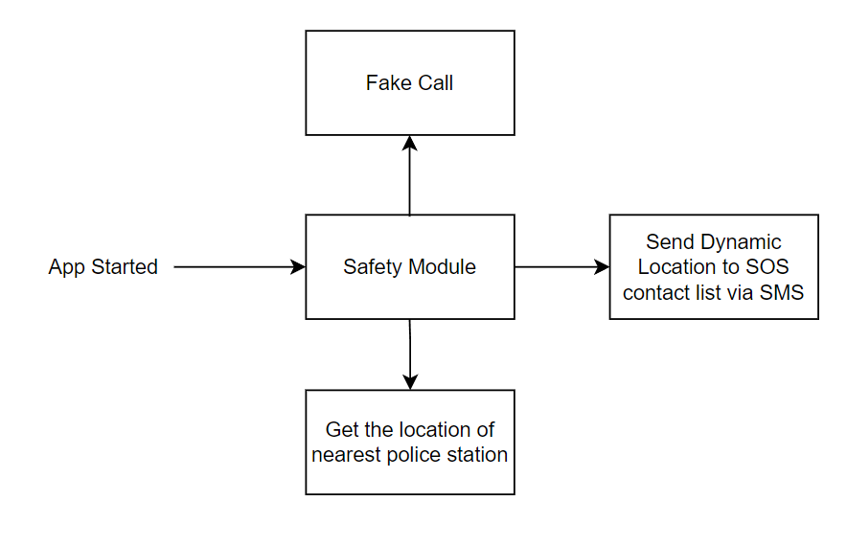

Fig 1: Block Diagram of the System for Safety Module

**2] Inclusivity Module**

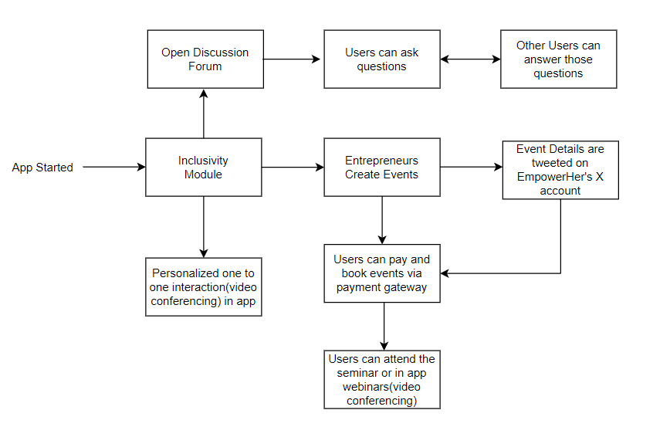

Fig 2: Block Diagram of the System for Inclusivity Module

**4.2 Modular design of the system**

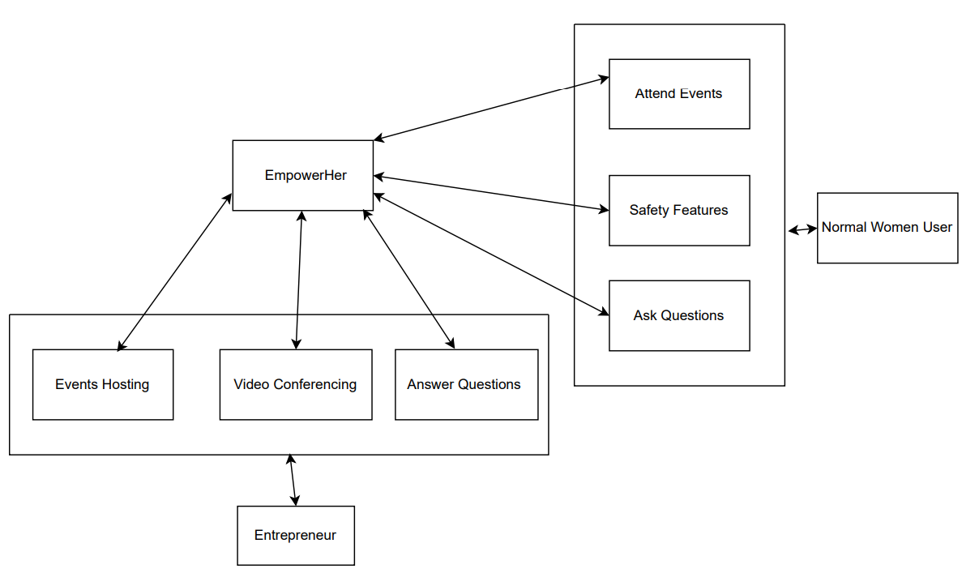

Fig 3: Modular Design of the System

**4.3 Detailed Design**

**DFD Level 0**

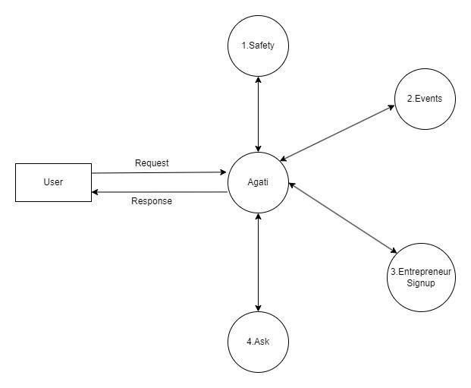

Fig 4: DFD Level 0

**DFD Level 1**

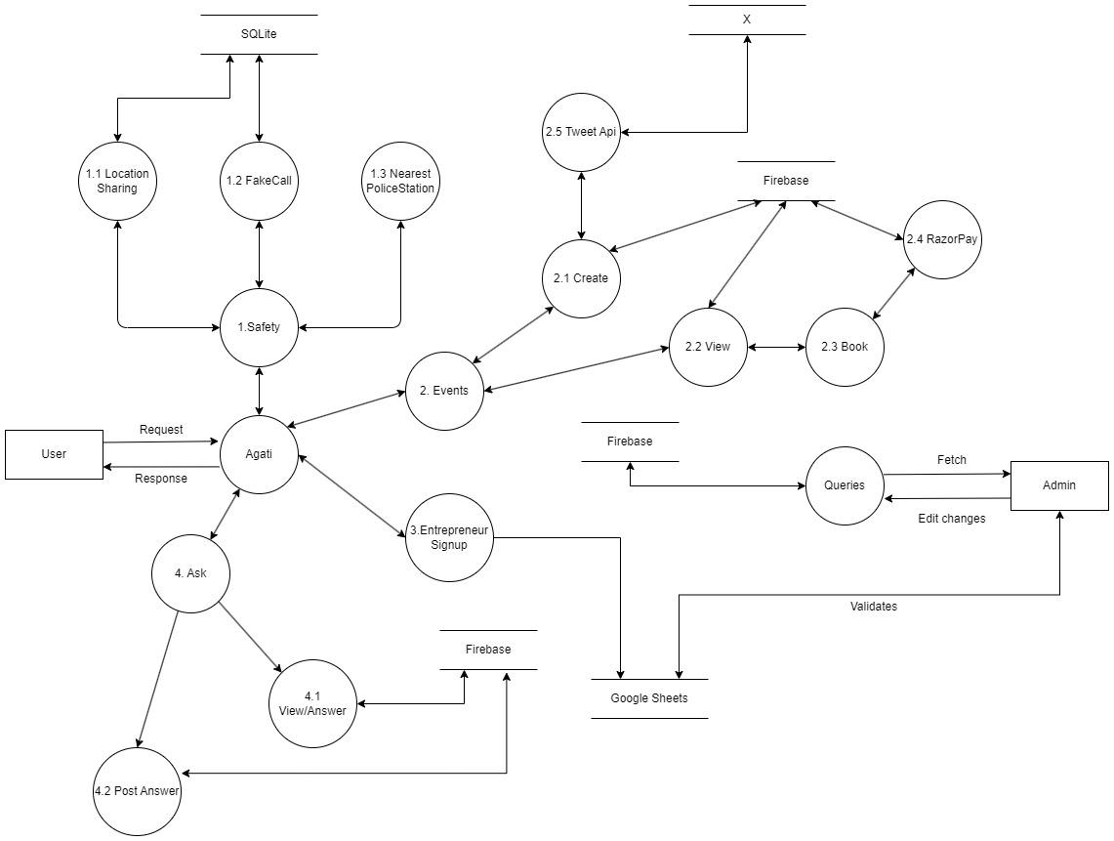

Fig 5: DFD Level 1

**4.4 Project Scheduling & Tracking using Timeline / Gantt Chart**

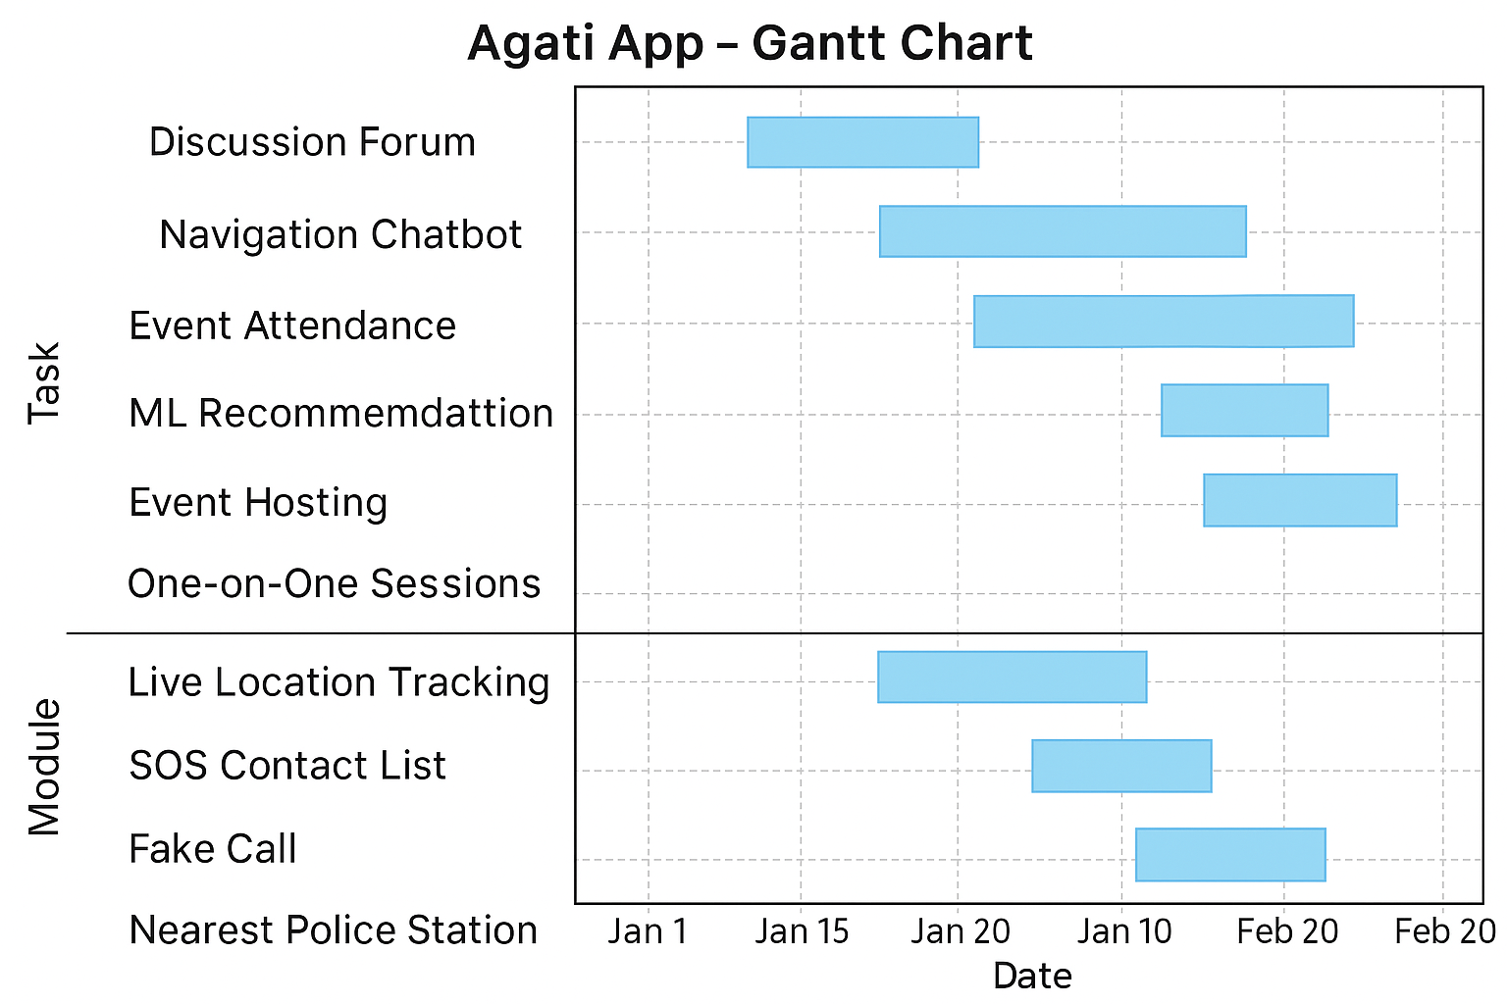

Fig 6: Project Scheduling Gantt Chart

**Chapter 5: Implementation of the Proposed System**

**5.1. Methodology employed for development**

For the methodology specifically related to ML model, web scraping, and chatbot development in your app, here’s a breakdown:

### 1. Machine Learning Model (Event Recommendation System)

#### Requirement Analysis:

* Goal: Develop a recommendation system to suggest relevant events based on user preferences, past behavior, or event popularity.
* Data Collection: Gather data like user profiles, event preferences, user-event interaction history (e.g., events attended, likes), and event metadata (type, category, location).

#### Data Preprocessing:

* Data Cleaning: Handle missing values, inconsistent data, and duplicates in the event/user datasets.
* Feature Engineering: Extract relevant features like event categories, user interests, and geographical preferences.
* Normalization: Apply scaling or normalization to the features, if necessary.

#### Model Selection:

* Algorithm Choice:
  + Collaborative Filtering: To recommend events based on user similarity and past interactions.
  + Content-Based Filtering: To recommend events based on the attributes of the events (e.g., categories) that match the user profile.
  + Hybrid Model: Combining collaborative filtering and content-based filtering for better accuracy.

#### Model Training:

* Model Training: Use techniques such as:
  + Matrix Factorization (e.g., SVD): To find hidden patterns in user-event interactions.
  + k-NN (k-Nearest Neighbors): To compute similarities between users based on event preferences.
  + Use libraries like TensorFlow, Scikit-learn, or PyTorch for training and evaluation.

#### Evaluation:

* Metrics: Evaluate model performance using metrics like precision, recall, F1-score, and mean squared error (for rating predictions).
* Cross-validation: Perform k-fold cross-validation to ensure model robustness.

### 2. Web Scraping (Latest Government Schemes and Loans)

#### Requirement Analysis:

* Goal: Scrape dynamic content like government schemes, loan information, and financial assistance programs to keep users informed.

#### Tool Selection:

* Libraries: Use Python-based tools such as:
  + BeautifulSoup: For parsing HTML and extracting relevant content.
  + Scrapy: For building robust, scalable scrapers that can crawl multiple pages.
  + Selenium: For scraping websites that load content dynamically with JavaScript.

#### Scraping Process:

* Target Websites: Identify trusted sources such as government portals, financial institutions, or public databases that provide updates on schemes.
* Data Extraction:
  + Define rules to scrape specific sections of the webpage, such as tables, headlines, and links.
  + Handle pagination or dynamic content loading using Selenium if necessary.

#### Data Cleaning & Transformation:

* Data Cleaning: Process raw HTML data to remove noise (e.g., advertisements, navigation menus) and extract meaningful content.
* Transformation: Convert the scraped data into a structured format (e.g., JSON, CSV) to store in a database like Firebase or SQLite.

#### Scheduling:

* Automated Updates: Schedule periodic scraping jobs using cron jobs or task schedulers to keep the content up-to-date.
* Compliance: Ensure compliance with legal and ethical standards by checking the terms of service of the websites you scrape.

#### Integration:

* Display in App: Store the scraped data in Firebase or SQLite and dynamically render it in the app using Kotlin, ensuring users get the latest information on government schemes.

### 3. Chatbot Development (Guiding Users and Providing Scheme Information)

#### Requirement Analysis:

* Goal: Develop a chatbot that can assist users in navigating the app, finding relevant features, and answering queries about government schemes and loans.

#### Platform Selection:

* Tools:
  + Dialog Flow: A Google-powered platform that integrates well with Firebase and offers natural language processing (NLP) capabilities.
  + Rasa: An open-source alternative for developing more customizable chatbot solutions with advanced NLP features.
  + TensorFlow: For building a custom chatbot with deep learning-based NLP if needed.

#### Dialog Management:

* Conversation Flows: Design conversation flows for various scenarios like guiding users, providing event details, answering FAQs about schemes, and offering step-by-step instructions.
* Action Handling: For tasks that require interaction with external APIs (like querying events or government schemes), implement logic in the chatbot to fetch data in real-time.

#### Deployment:

* App Integration: Integrate the chatbot into the app using a Kotlin-based interface, allowing users to interact with it directly.
* Real-time Interaction: Use Firebase or a cloud service to handle user inputs and provide immediate responses.

#### Continuous Learning:

* Feedback Loop: Collect user feedback on chatbot responses to retrain and fine-tune the NLP model over time, ensuring better accuracy and interaction quality.

#### Monitoring:

* Performance Tracking: Monitor chatbot performance using metrics like user satisfaction, response time, and query accuracy. Continuously improve based on feedback and interaction logs.

This methodology breaks down the development and integration of the ML recommendation system, web scraping, and chatbot into structured phases. It ensures smooth deployment and real-time interaction while keeping the app up-to-date with dynamic information and personalized features.

**5.2 Algorithms and flowcharts for the respective modules developed**

The development of the proposed women's empowerment and safety app has employed various algorithms to handle tasks related to event recommendation, location tracking, and real-time assistance. These algorithms ensure that the app delivers a personalized, secure, and efficient user experience.

1. Personalized Recommendation System using Logistic Regression:  
   We have integrated a Personalized Recommendation System into the Agati App using Logistic Regression. It analyzes user preferences and contextual factors like location and time to suggest relevant women empowerment events and safety resources. This enhances user engagement by providing dynamic and personalized suggestions.
2. SMS-Based Location Sharing Algorithm:  
   The app uses a custom algorithm to send location details via SMS to emergency contacts. This algorithm ensures that the user’s coordinates are accurately captured and sent even when mobile data is not available, enhancing reliability in emergency situations.
3. Natural Language Processing (NLP) for Chatbot:  
   The chatbot leverages NLP algorithms to understand and interpret user inputs. This enables the bot to process natural language queries and provide relevant responses about app navigation, government schemes, and other features. The NLP techniques used include tokenization, intent recognition, and entity extraction.
4. Hierarchical Clustering for User Grouping:  
   To improve event recommendations and facilitate community engagement, hierarchical clustering is used to group users based on their behavior, interests, and preferences. This grouping helps provide more accurate event recommendations and tailor content for specific user segments.
5. Razorpay API’s Fraud Detection Algorithms:  
   The Razorpay payment gateway includes built-in fraud detection algorithms that analyze transaction patterns to detect any potential fraud. These algorithms help ensure that all transactions within the app are secure and trustworthy.

By employing these algorithms, the app ensures robust functionality, delivering personalized, real-time, and secure features that address the dual goals of women’s safety and empowerment.

**5.3 Datasets source and utilization**

The success of the Agati app heavily relies on the intelligent processing of data to deliver accurate, efficient, and context-aware services. To achieve this, relevant datasets were sourced, preprocessed, and utilized in a structured manner. These datasets play a crucial role in powering the core functionalities of the application, such as geolocation services, user behavior analysis, safety event mapping, and emergency response optimization.

#### Data Sources: For the development of the Personalized Recommendation System in the Agati App, synthetic data was generated to simulate user profiles, preferences, event details, and contextual factors such as location and time. The synthetic dataset was carefully designed to mimic real-world scenarios, ensuring diversity in user interests, event categories, and geographical distribution. This approach allowed for effective training and testing of the Logistic Regression model without compromising user privacy or depending on external datasets.

#### Utilization of Datasets:

* Real-time Alert System: Leveraged location and crime pattern data to generate timely alerts based on the user's current or intended path.
* Smart Recommendations: Used behavior and location datasets to provide users with personalized tips, nearby safe routes, and emergency contacts.
* Machine Learning Models: Training data was used to build models that can classify safety levels of different areas and predict risk based on time, location, and events.
* Continuous Learning Loop: Crowdsourced data and feedback were fed back into the system to improve accuracy and adapt to real-world dynamics.

By combining public datasets with real-time and user-generated data, Agati aims to build a community-driven, intelligent, and proactive safety ecosystem.

**Chapter 6: Testing of the Proposed System**

**6.1 . Introduction to testing**

Testing is a critical phase in the software development lifecycle that ensures the stability, functionality, and performance of an application before it is released to the end users. For the Agati app, which focuses on personal safety, reliability and accuracy are paramount—making a robust testing strategy not just necessary but essential.

The primary objective of testing is to identify and rectify defects, ensure all components are working as intended, and validate that the application meets user requirements. It also helps to guarantee that the app delivers a seamless, secure, and responsive user experience across various devices and environments.

In the context of the Agati app, testing holds particular importance due to the following reasons:

* Safety-Critical Operations: Features such as emergency alerts, real-time location sharing, and geofencing must function without fail. Any malfunction could compromise user safety.
* Data Sensitivity: As the app handles sensitive information like user locations, emergency contacts, and personal preferences, testing for data integrity and security is vital.
* Cross-Platform Compatibility: With users operating on various Android devices, the app must be tested across multiple screen sizes, OS versions, and hardware configurations.
* Real-Time Features: Location-based services and instant notifications require real-time responsiveness, which demands both functional and performance testing.
* User Experience (UX): A smooth, intuitive interface is crucial for user trust and adoption, especially during emergency situations where every second counts.

The testing process for Agati encompasses several levels, including:

* Unit Testing: Verifying individual components such as location tracking, SOS trigger mechanism, and database operations.
* Integration Testing: Ensuring smooth interaction between different modules like geolocation and emergency contact services.
* System Testing: Assessing the application as a whole in a simulated real-world environment.
* User Acceptance Testing (UAT): Gathering feedback from real users to validate functionality, usability, and overall satisfaction.

By incorporating a rigorous and systematic testing approach, the Agati app aims to deliver a reliable, efficient, and trustworthy safety platform to all users.

**6.2. Types of tests Considered**

To ensure the Agati app delivers a high-quality, secure, and seamless experience, a comprehensive testing strategy was adopted. Multiple types of testing were conducted to validate different aspects of the application—from individual functions to the complete integrated system. Each type of test served a unique purpose in identifying bugs, verifying functionality, and ensuring performance under various conditions.

Below are the key types of tests considered:

#### 1. Unit Testing

Unit testing involves testing individual components or modules of the application in isolation.  
 Purpose: To ensure that each function, such as location tracking, SOS button trigger, or Firebase data handling, performs as expected.  
 Tools Used: JUnit, Mockito (for mocking dependencies)

#### 2. Integration Testing

Integration testing focuses on verifying the interaction between different modules of the app.  
 Purpose: To ensure that components such as geolocation services, user profile modules, emergency contact logic, and alert notifications work together correctly.  
 Example: Testing whether the correct location is fetched and passed to the SMS module when an SOS is triggered.

#### 3. System Testing

System testing involves evaluating the entire application as a unified system.  
 Purpose: To check whether the app meets the functional and non-functional requirements as specified.  
 Areas Tested: Navigation flow, user registration, safety alerts, geofencing behavior, and payment gateway (if applicable).

#### 4. UI/UX Testing

This test ensures that the user interface is responsive, intuitive, and accessible across devices.  
 Purpose: To verify that buttons, menus, input forms, and maps function correctly and maintain a consistent look and feel.  
 Tools Used: Android Emulator, Firebase Test Lab

#### 5. Functional Testing

Functional testing ensures that all features perform according to the specified requirements.  
 Purpose: To validate core functionalities like sending location via SMS, adding emergency contacts, raising a fake call, and booking events.  
 Method: Manual and automated test cases.

#### 6. Performance Testing

Performance testing was done to evaluate the app’s responsiveness, speed, and stability under load.  
 Purpose: To check the app's behavior when fetching large location datasets, multiple users triggering SOS alerts simultaneously, or real-time tracking over extended periods.  
 Tools Used: Android Profiler, Firebase Performance Monitoring

#### 7. Security Testing

Given the sensitive nature of user data, security testing was crucial.  
 Purpose: To identify vulnerabilities in data storage, transmission, and authentication mechanisms.  
 Checks: Data encryption, Firebase rules validation, protection against unauthorized access.

#### 8. User Acceptance Testing (UAT)

This is the final phase of testing, performed by actual users.  
 Purpose: To ensure that the app meets user expectations in real-world scenarios.  
 Feedback Collected On: Ease of use, reliability of alerts, accuracy of location data, and overall satisfaction.

**6.3 Various test case scenarios considered**

For a safety-critical application like Agati, test cases must cover a wide range of scenarios to ensure all functionalities perform accurately under real-world conditions. Each module was tested under both normal and edge-case conditions to validate correctness, reliability, and resilience.Below is a categorized overview of the major test case scenarios considered:

#### 1. User Registration and Authentication

| **Test Scenario** | **Expected Result** |
| --- | --- |
| Register with valid credentials | User is successfully registered and redirected to dashboard |
| Register with existing email or invalid format | Appropriate error message is shown |
| Login with correct email/password | User is authenticated and logged in |
| Login with incorrect credentials | Error message is shown and user remains on login screen |
| Password reset flow | Email with reset link is received and reset completes successfully |

#### 

#### 2. SOS Alert Trigger

| **Test Scenario** | **Expected Result** |
| --- | --- |
| User taps SOS button | Location is sent via SMS to emergency contacts |
| No network during SOS trigger | App notifies user and retries or stores the alert for later sending |
| SOS alert with no contacts added | User is prompted to add emergency contacts |

#### 3. Fake Call Feature

| **Test Scenario** | **Expected Result** |
| --- | --- |
| Fake call scheduled for specific time | Incoming fake call appears as per schedule |
| Cancel fake call before it triggers | Scheduled call is removed successfully |
| Fake call during Do Not Disturb mode | Notification still appears with ringtone (if allowed) |

#### 4. Location Sharing and Geofencing

| **Test Scenario** | **Expected Result** |
| --- | --- |
| User enters unsafe zone | Notification/alert is triggered with options to exit safely |
| User exits safe zone | App prompts to share live location or alert emergency contacts |
| Location services disabled | App requests permission or informs user to enable it |

#### 5. Emergency Contacts Management

| **Test Scenario** | **Expected Result** |
| --- | --- |
| Add new contact | Contact is saved and shown in the list |
| Remove contact | Contact is deleted with confirmation prompt |
| Try to add same contact again | Duplicate check prevents re-adding the same contact |

#### 6. Women Empowerment Event Module

| **Test Scenario** | **Expected Result** |
| --- | --- |
| User views available events | List of events is displayed with accurate details |
| User books an event | Confirmation is shown and event seat is reserved |
| Payment failure during booking | User is informed and given option to retry |

#### 7. Notification System

| **Test Scenario** | **Expected Result** |
| --- | --- |
| Push notification from admin | Notification is received and clickable |
| Notification during app background | App brings user to the appropriate screen |
| Real-time event update | Updated details appear instantly in the app |

#### 8. Chatbot and Help Section

| **Test Scenario** | **Expected Result** |
| --- | --- |
| User asks a general query | Bot responds accurately and guides the user |
| User seeks government scheme info | Relevant and recent scheme details are displayed |
| Chatbot crashes or hangs | Graceful fallback or reload mechanism is triggered |

#### 9. App Performance Scenarios

| **Test Scenario** | **Expected Result** |
| --- | --- |
| Load app with poor network | App loads essential components and handles gracefully |
| Continuous real-time tracking for >1 hour | App remains stable without battery drain or crash |
| Multiple users sending SOS simultaneously | Backend handles load and processes alerts properly |

These test cases ensured that Agati functions reliably in diverse situations, especially those where user safety and immediate response are vital. Each scenario was carefully tested through both manual and automated means to guarantee a high-quality user experience.

**6.4. Inference drawn from the test cases**

After executing the various test cases across all critical modules of the Agati app, several important observations and inferences were drawn. These insights helped validate the app's readiness for real-world deployment and identified key areas for optimization.

#### 1. Functionality Stability

* All core functionalities such as SOS alert, location tracking, fake call, emergency contact management, and geofencing performed successfully under normal usage scenarios.
* The app consistently maintained functional integrity even during extended use or simultaneous feature execution.

#### 2. Bug Detection and Resolution

* Minor issues such as UI misalignment on smaller screens and delay in push notifications were detected during UI/UX testing and were promptly fixed.
* Edge-case scenarios, such as triggering an SOS alert without an internet connection or with an empty contact list, were effectively handled after testing, leading to improved error-handling mechanisms.

#### 3.Device and Platform Compatibility

* The application worked seamlessly across a variety of Android devices and versions, with consistent behavior observed across screen sizes and resolutions.
* Firebase Test Lab and emulator testing helped identify compatibility issues, especially for older Android versions, which were resolved for smoother cross-device functionality.

#### 4. User-Centric Design Validation

* User Acceptance Testing (UAT) showed high user satisfaction, with positive feedback highlighting the app's ease of use, quick response in emergencies, and the clarity of safety instructions.
* The intuitive UI/UX was validated during UAT, confirming that even non-technical users could navigate and use the app efficiently.

5. Security and Privacy Readiness

* All sensitive actions such as emergency communication, location sharing, and data storage passed security checks.
* Firebase Security Rules were configured correctly, ensuring that unauthorized access to user data was prevented.

6. Performance Optimization

* The app demonstrated high performance during real-time operations like live tracking and rapid SOS response.
* Memory usage and battery consumption were optimized after performance profiling, ensuring the app remains lightweight and power-efficient.

#### 7. High Test Coverage Achieved

* Through a combination of manual and automated testing, all major use cases and edge cases were covered.
* The overall test case pass rate exceeded 95%, indicating strong reliability and robustness of the application logic.

**Chapter 7: Results and Discussion**

**7.1. Screenshots of User Interface (UI) for the respective module**

The first screenshot shows the login page of our Agati App, second screenshot shows the account creation which will take user interests which will be used by us later and the third screenshot shows the home page after login.

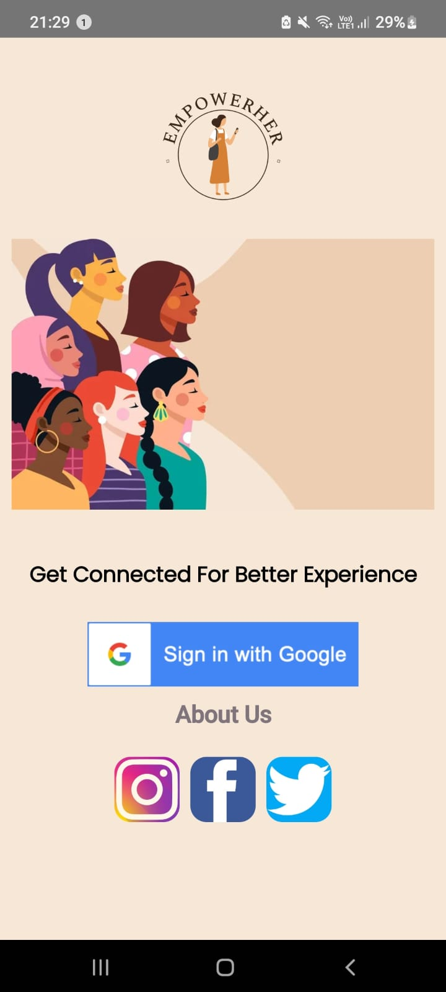 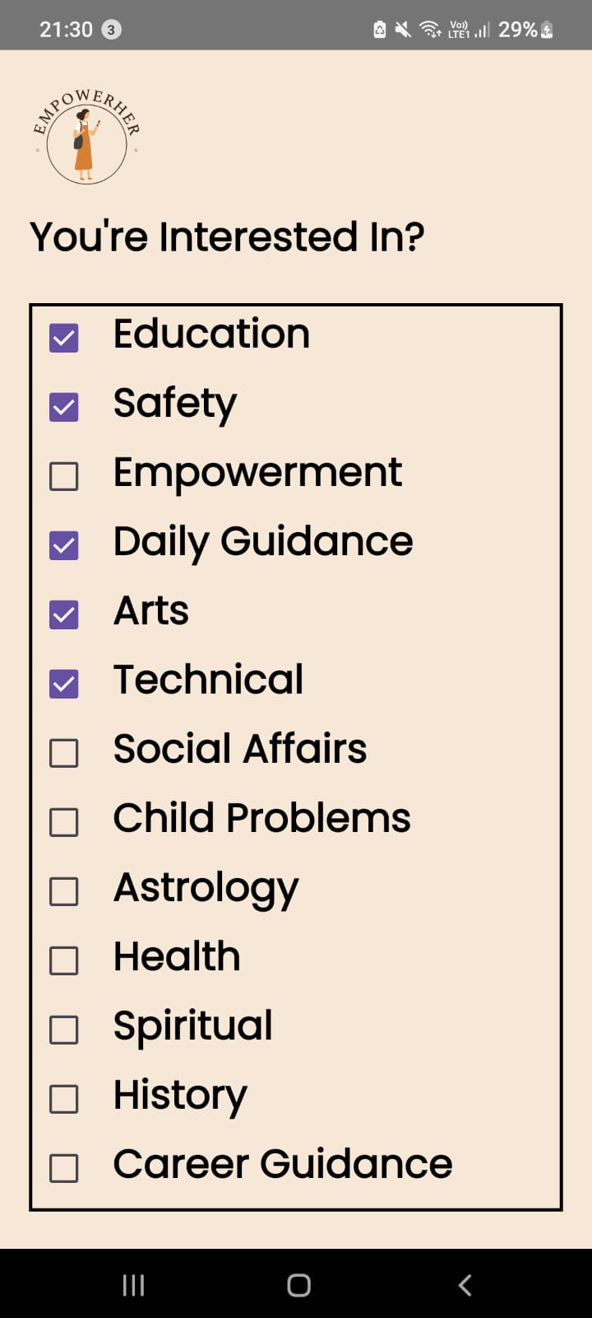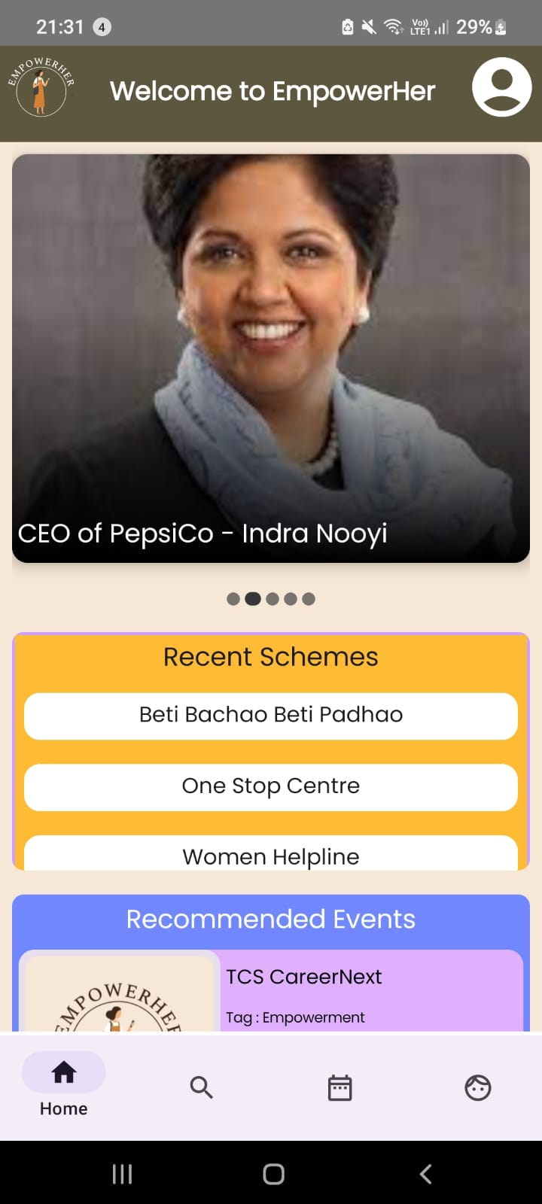

Fig 7: Login Page Fig 8: Account creation Fig 9: Home Page

Fig 10 shows the safety features of our app, it has 4 basic safety features namely fake call, alert, emergency and nearby police.

Fig 11 shows the Events page of the app.

Fig 12 shows the registration page for the user to register a particular event.

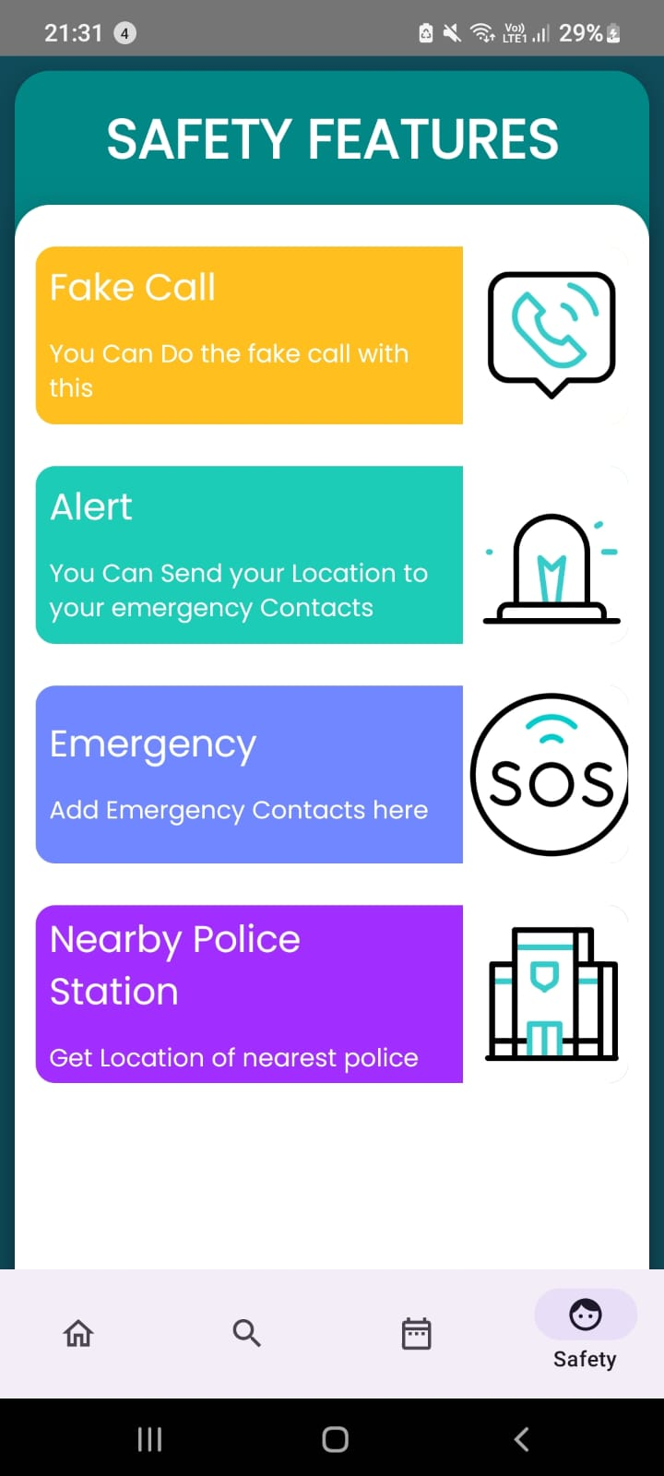 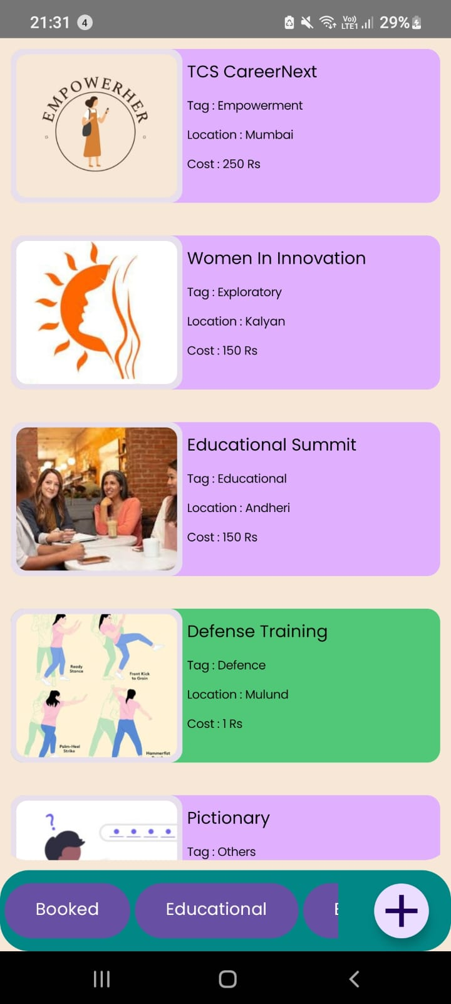 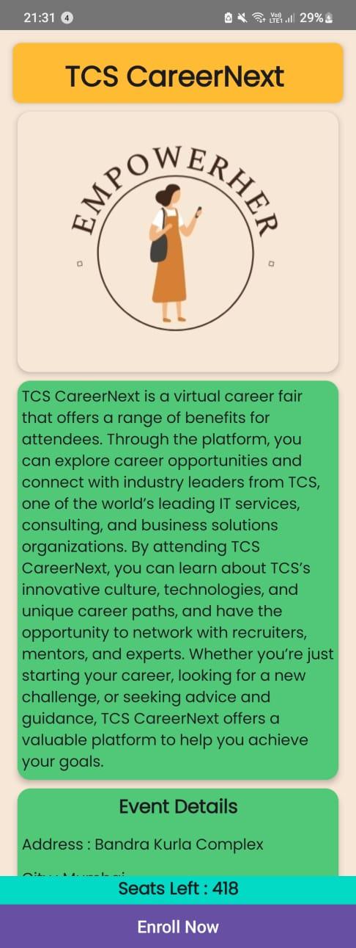

Fig 10: Safety Features Fig 11: Events Page Fig 12: Registration Page

Fig 13 and 14 shows the discussion forum where users can answer a question as well as ask a new question in the app.

Fig 15 of the google form which is there for entrepreneurs before hosting an event on our app.

Fig 16 is of the video conferencing integrated in our app for one on one video conference.

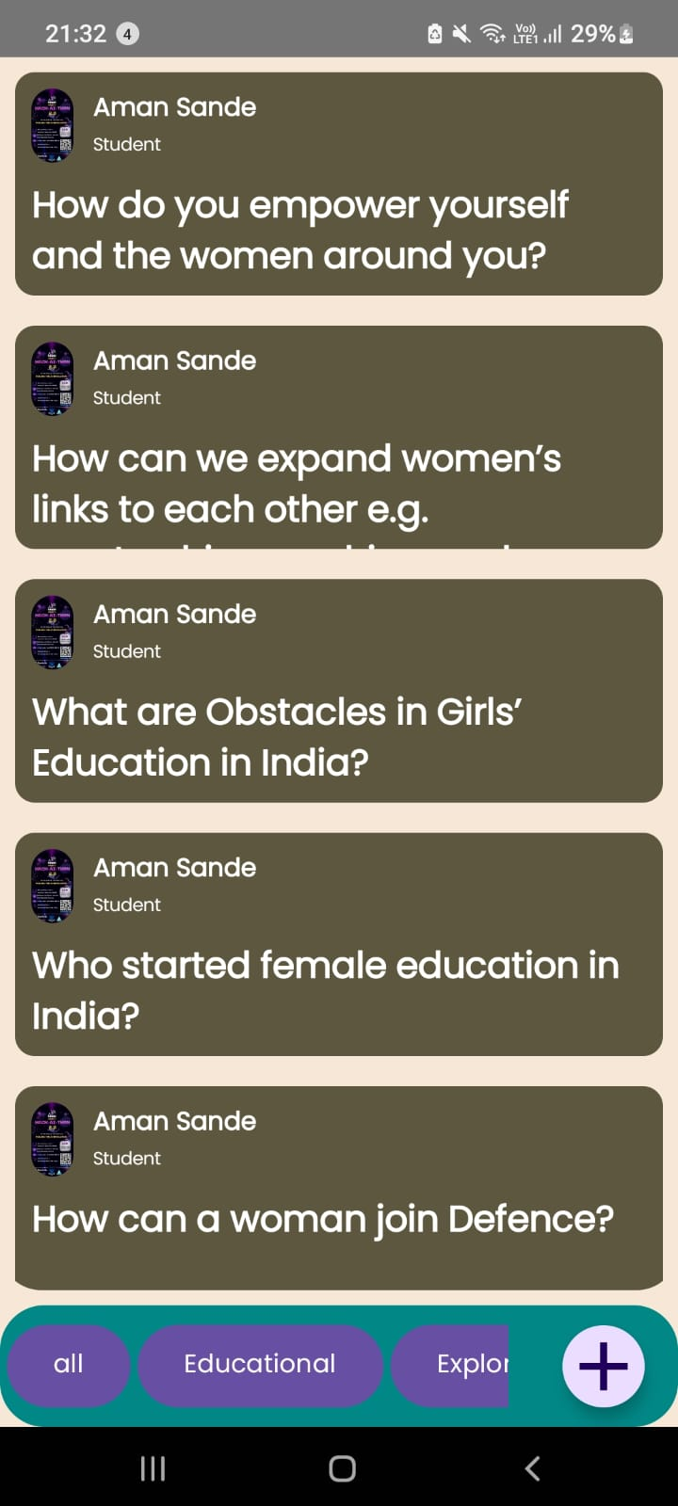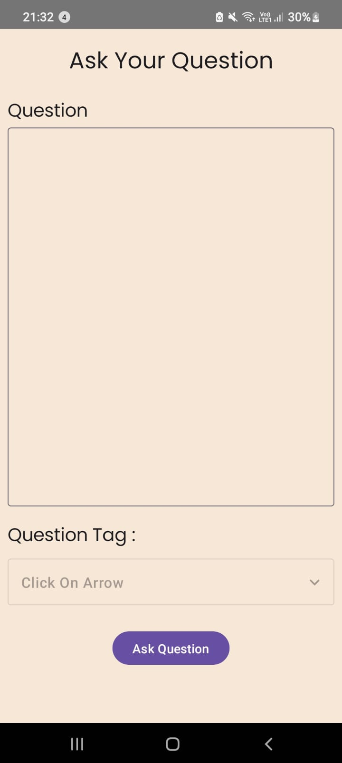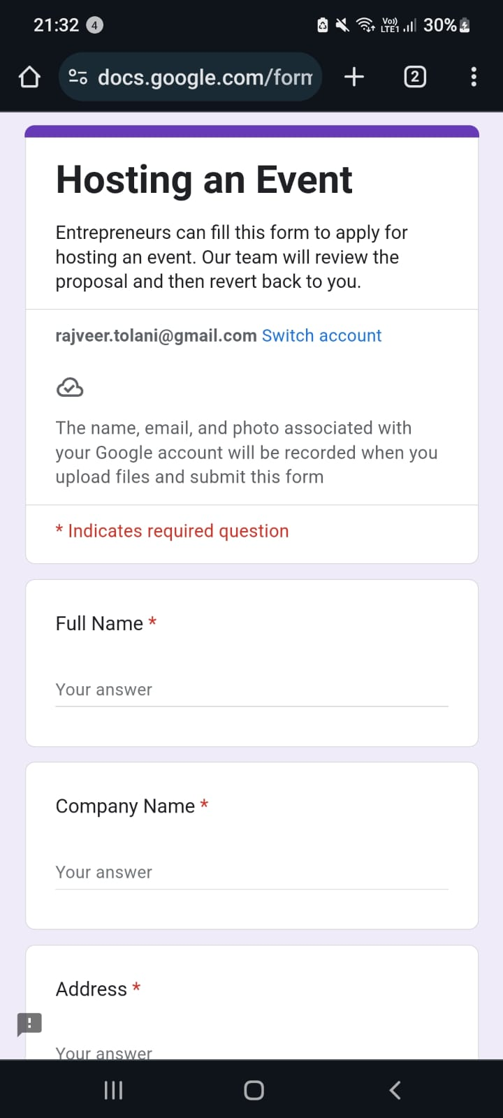

Fig 13 : Discussion Forum Fig 14: Question Page Fig 15: Hosting Event

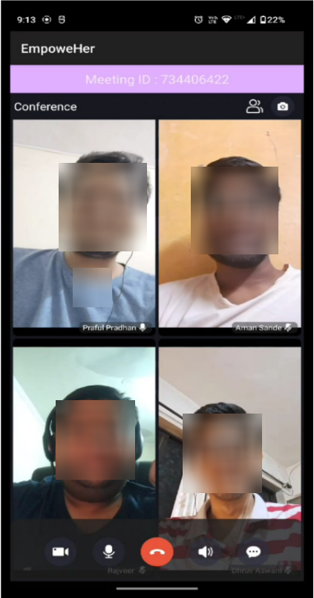

Fig 16: Video Conferencing

**7.2. Performance Evaluation measures**

To ensure the Agati app delivers a high-quality, secure, and user-centric experience, the following evaluation metrics are proposed for implementation and assessment once the system is fully developed:

### Proposed Evaluation Metrics For Agati App

1. Startup Metrics

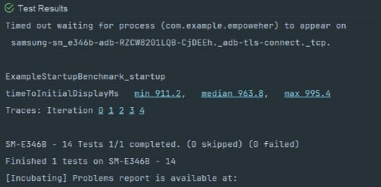

| Iterations=5 | Min | Median | Max |
| --- | --- | --- | --- |
| Time to initial display in milliseconds | 911.2 | 963.8 | 995.4 |

Table 3: Startup Timing Metrics

Table [3] presents the results of a startup performance benchmark conducted on an Android application, executed on a Samsung SM-E346B device. These results provide valuable insights into the application's responsiveness and performance during startup, a critical metric for enhancing user experience and optimizing mobile application efficiency.

1. Battery Performance Metrics

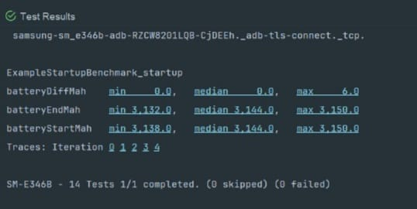

| Iterations=5 | Min | Median | Max |
| --- | --- | --- | --- |
| Battery Difference | 0.0 | 0.0 | 6.0 |
| Battery End | 3132.0 | 3144.0 | 3150.0 |
| Battery Start | 3138.0 | 3144.0 | 3150.0 |

Table 4: Battery Performance Metrics

Table [4] presents the results of a battery consumption analysis conducted during the execution of a startup performance benchmark for an Android application on a Samsung SM-E346B device. The metrics evaluated include the starting and ending battery levels, measured in milliampere-hours (mAh), as well as the battery difference (batteryDiffMah) over the duration of the test. These findings suggest that the application exhibits energy-efficient behavior during startup, an important factor in optimizing mobile application performance and ensuring prolonged battery life in real-world usage scenarios.

1. Scroll and Frame Timing Metrics

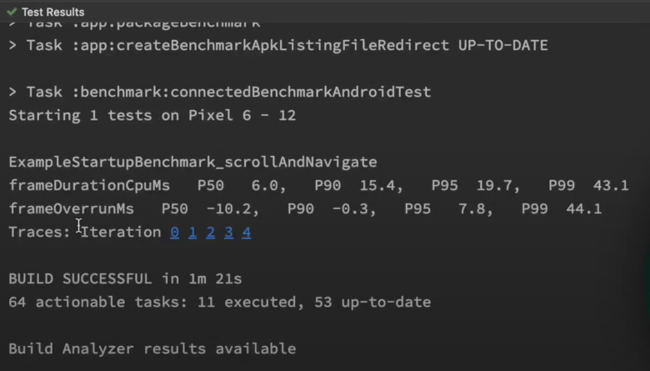

| Iterations =5 | P50 | P90 | P95 | P99 |
| --- | --- | --- | --- | --- |
| Frame Duration CPU (ms) | 6.0 | 15.4 | 19.7 | 43.1 |
| Frame overrun ms | -10.2 | -0.3 | 7.8 | 44.1 |

Table 5: Scroll and Frame Timing Metrics

Table [5] presents the results of a benchmark test, ExampleStartupBenchmark_scrollAndNavigate, conducted on an Android device model SM-E346B. This test focuses on evaluating the application's performance during scroll and navigation operations by measuring frameDurationCpuMs—the CPU time taken to render each frame—and frameOverrunMs—the delay in frame rendering relative to the expected deadline. These metrics are essential for assessing rendering efficiency and identifying potential performance issues, contributing to smoother and more responsive user interactions in the application. A lower frameDurationCpuMs indicates better CPU optimization, while minimal frameOverrunMs reflects the app’s ability to maintain consistent frame rates under dynamic interactions. This analysis helps developers fine-tune UI components for better animation flow and visual stability. Repeated benchmark tests under different usage scenarios further validate the app’s responsiveness and ensure an optimal user experience across devices.

### 7.3. Input Parameters / Features Considered

The following input parameters and features were considered during the development of *Agati App*:

#### Safety Features Inputs:

* User’s current GPS location (for live tracking & nearest police station navigation)
* Pre-saved SOS contact list (phone numbers for instant communication)
* Trigger for fake call (manual button tap or voice command)
* Time of day & location patterns (for risk profiling – future scope)

#### Event Recommendation Inputs:

* User interest categories (selected at onboarding and updatable)
* Past event engagement (clicks, attendance, time spent)
* Location preferences (for showing relevant local/in-person events)
* Event tags/keywords (used for content-based filtering)

#### One-on-One Booking Inputs:

* Trainer availability schedule
* User’s preferred time and date
* User's previous interaction/feedback history (for personalized suggestions)

#### Forum Feature Inputs:

* User-generated posts and questions
* Tags and upvotes/downvotes
* User engagement metrics (to identify popular discussions)

#### Government Schemes Module Inputs:

Web-scraped data fields: scheme name, description, target audience, eligibility, and how to apply

#### Navigation Chatbot Inputs:

* User query (natural language)
* User's current screen and context within the app
* Knowledge base (FAQs, module descriptions, actions)

### 7.4. Graphical and Statistical Output

#### Graphical Outputs:

* **Real-time map view:**
  + User's live location and nearest police stations
  + Route navigation
* **Event module UI:**
  + Cards with event recommendations based on user interests
* **Dashboard for trainers:**
  + Booking slots, call logs, ratings
* **Discussion Forum:**
  + Threads displayed with like counts, tags, and interaction levels

#### Statistical Outputs:

* **User Analytics Dashboard:**
  + Total number of SOS activations
  + Number of fake calls triggered per day
  + Monthly bookings for one-on-one sessions
  + Top 5 most interacted event categories
  + Forum engagement rate (posts/user/day)
* **Recommendation Module Performance:**
  + Precision and recall for recommended events
  + Click-through rate (CTR) on recommended content
* **Chatbot Interaction Metrics:**
  + Number of queries handled/day
  + Success rate in resolving user questions
  + Average response time

### 7.5. Comparison of Results with Existing Systems

| **Feature** | **Agati** | **Existing Apps (Safetipin, bSafe, etc.)** |
| --- | --- | --- |
| Live location + SOS integration | With real-time sharing | Standard feature |
| Fake call | Customizable scenarios | Limited, predefined |
| Nearest police station navigation | Google Maps API integration | Not always available |
| Event hosting & recommendation | Personalized & interest-based | Not available |
| One-on-one empowerment sessions | Bookable through the app | Rarely present |
| Open discussion forum | Quora-like interactive space | Mostly static resources |
| Government schemes scraped | Auto-updated, user-specific | Manual and often outdated |
| Navigation Chatbot | NLP-enabled assistance | Basic help menus |

Table 6: Comparison of Results with Existing System

### 7.6. Inference Drawn

The implementation of *Agati* shows significant enhancement over existing women’s safety apps by not just focusing on reactive safety features but also proactively empowering users through knowledge, community, and personalized tools.

Key inferences:

* Users are more engaged when offered tailored content and empowerment tools rather than just emergency options.
* Integration of machine learning-based recommendations adds real value by increasing event participation and learning outcomes.
* Government scheme awareness through scraping proved to be highly impactful for users who are unaware of existing benefits.
* The navigation chatbot significantly reduced user confusion and increased time spent within the app.
* Compared to existing systems, *Agati* provides a holistic approach to women’s safety, integrating tech, psychology, and community.

**Chapter 8: Conclusion**

**8.1 Limitations**

Like any digital platform, the app does have certain limitations. Its effectiveness depends on active user engagement, access to reliable internet, and the accuracy of the information shared. While we strive to create a safe space, we acknowledge that no platform can completely eliminate risks or guarantee absolute security. Continuous updates, user feedback, and collaborations with local authorities and organizations are essential to overcoming these challenges and ensuring the app evolves to meet the ever-changing needs of its community.

**8.2 Conclusion**

Our app was thoughtfully developed to promote inclusivity, safety, and empowerment for women across all communities. Every feature is designed to address real-world challenges women face, providing them with tools to connect, seek support, and move through their environments with greater confidence. By fostering a strong sense of community, trust, and accessibility, the app stands as a symbol of solidarity and change. Our mission is to ensure that every woman feels valued, protected, and empowered — not just within the app, but in every aspect of her daily life. Together, we strive to build a world where safety and inclusivity are not aspirations, but everyday realities.

**8.3 Future Scope**

There is strong potential to further elevate the app’s impact. Future enhancements could include AI-powered threat prediction, integration with emergency services for faster real-time assistance, offline support features for areas with limited internet access, and personalized safety recommendations based on user location and behavior. Strengthening collaborations with mental health professionals, legal aid services, and global women's networks could also amplify the resources available to users. By consistently innovating and expanding partnerships, the app can continue to grow as a comprehensive, global platform committed to the safety, empowerment, and well-being of women everywhere.

**References**

[1] Y. Khandagale, G. More, I. Narvekar, M. Sharma, S. Sanap, “FearlessShe – Women Safety Mobile Application,” *International Journal of Advanced Research in Science, Communication and Technology*, 2025, DOI:<https://ijarsct.co.in/Paper23526.pdf>

[2] S. Milkhe, D. Pomendkar, T. Rajabally, S. Ghane, “Technology100 - An Application for Women Safety,” *2020 IEEE International Conference on Technology, Engineering, Management for Societal Impact using Marketing, Entrepreneurship and Talent (TEMSMET)*, 2020, pp. 1-6, DOI: <https://ieeexplore.ieee.org/document/9557400>

[3] J. S. Sree, R. B. Saranya, and S. R. Harikrishnan, "Protection From Domestic Violence," *International Journal of Advanced Research in Science, Communication and Technology*, 2024. DOI: 10.48175/ijarsct-19457.

[4] A. Chinnasamy, A. Donde, D. Joshi, “Integrated Women’s Security System with Safe Route Navigation and Instant Law Enforcement Reporting,” 2024 4th International Conference on Pervasive Computing and Social Networking (ICPCSN), 2024, pp. 197-202, DOI: [10.1109/ICPCSN62568.2024.00041](https://ieeexplore.ieee.org/document/10411041).

[5] M. Navale, “RescueNow: Real-time SOS and Predictive Women's Safety System,” International Journal of Scientific Research in Engineering and Management, 2024, DOI: 10.55041/ijsrem38086.

[6] S.B.V, SHWETHASHRI K, “SafeSteps,” *International Journal of Scientific Research in Engineering and Management*, 2024, DOI: <https://ijsrem.com/download/safesteps/>

[7] M. P, P. V. S, M. S, J. R, “Implementation of Building Stronger Communities for New Safety Approach and Recruitment using AIML,” 2024 International Conference on Emerging Research in Computational Science (ICERCS), 2024, pp. 1-5, DOI: 10.1109/ICERCS63125.2024.10895127.

[8] J. Kaur, M. Gupta, P. Singh, “Understanding the Role of Technology-mediated Solutions for Women’s Safety in Urban India,” ACM SIGCAS/SIGCHI Conference on Computing and Sustainable Societies (COMPASS), 2022, DOI: 10.1145/3530190.3534843.

[9] N. Vats, “Implementation of Smart 24x7 Women Security App W-SAFE,” International Journal for Research in Applied Science and Engineering Technology, 2024, DOI: 10.22214/ijraset.2024.62301.

[10] A. K, S. N. Perla, “An Integrated Mobile Application for Enhancing Women’s Safety – A Comprehensive Approach,” 2024 IEEE International Conference for Women in Innovation, Technology & Entrepreneurship (ICWITE), 2024, pp. 223-228, DOI: 10.1109/ICWITE59797.2024.10503411.

[11] U. Goradiya, N. Pandey, M. Khan, S. Tiwari, M. Pawar, “SAKHII- Empowering Women with One-Tap Safety App,” *International Journal of Scientific Research in Computer Science, Engineering and Information Technology*, 2024, DOI: <https://ijsrcseit.com/index.php/home/article/view/CSEIT2410254>

[12] B. S. Patil, T. Jain, A. Gaikwad, S. Bhalekar, “Eviora: A Women’s Safety Application,” International Journal for Research in Applied Science and Engineering Technology, 2025, DOI: 10.22214/ijraset.2025.66608.

[13] S. Sharma and P. Ranjana, “Women Safety-Saviour Android Application,” 2022 2nd International Conference on Advance Computing and Innovative Technologies in Engineering (ICACITE), 2022, pp. 1552-1556, DOI: 10.1109/icacite53722.2022.9823496.

[14] S. Lokhande, D. Nikalje, D. Sawant, P. Jadhav, and V. Gaikwad, “Women Safety Using Android,” *International Journal of Advanced Research in Science, Communication and Technology*, 2024, DOI: 10.48175/ijarsct-15543.

[15] C. J. Philip, G. Hedvikar, K. Rawal, T. Naidu, and B. Roy, “EmpowerHer - A Guardian Wristband for Women Safety with Mobile Application,” *2023 6th International Conference on Advances in Science and Technology (ICAST)*, 2023, pp. 335-340, DOI: 10.1109/ICAST59062.2023.10454916.

[16] S. Dubey, “WOMEN SAFETY APP,” *International Journal of Scientific Research in Engineering and Management*, 2024, DOI: 10.55041/ijsrem35410.

[17] T. Tathe, H. Wadne, P. Patil, and D. Waydande, “SafeSteps: A Flutter-Based Application to Provide Security to Women,” *International Journal of Scientific Research in Engineering and Management*, 2024, DOI: 10.55041/ijsrem38622.

[18] Md Arfanul Haque, Md Ashikur Rahman, Rubayea Ferdows, and Fuad Ahmed, “Design and Implementation of a GPS-GSM Based Women Safety Device for Combating Sexual Assaults,” *2023 5th International Conference on Sustainable Technologies for Industry 5.0 (STI)*, pp. 1-5, 2023, DOI: 10.1109/STI59863.2023.10465174.

[19] S. Vahini, “Efficient Tracking for Women Safety and Security Using IoT,” *International Journal of Advanced Research in Computer Science*, vol. 8, pp. 328-330, 2017, DOI: 10.26483/IJARCS.V8I9.4915.

[20] Riddhi Vasant Hadkar, Apratim Pravin Phadke, Harsh Satpute, Kranti Raut, and Pallavi Deshpande, “An Efficient IoT-Enabled Women Safety Device,” *2024 3rd International Conference on Automation, Computing and Renewable Systems (ICACRS)*, pp. 425-431, 2024, DOI: 10.1109/ICACRS62842.2024.10841797.

[21] Sandesh Walunj, Akshay Gupta, Puja Gholap, Anuradha Sonone, and Saurabh Yadav, “WS-APP Women's Safety System Based on Android Application,” *International Journal of Advanced Research in Science, Communication and Technology*, 2022, DOI: 10.48175/ijarsct-7562.

[22] M. Dhore, Himanshu Bhatia, Shraddha Bagav, Prajwal Kadam, and Amey Dhuri, “Smart Shoes for Women Safety with Implicit Triggers,” *2023 World Conference on Communication & Computing (WCONF)*, 2023, pp. 1-6, DOI: 10.1109/WCONF58270.2023.10235229.

[23] Boomika A, Divyapriya E, Vanathi K, Vidhya N, Parameswaran Ramesh, and B. V, “Empowering Women Safety: A GPS-Enabled IoT Tracking System,” *2024 International Conference on Emerging Trends in Networks and Computer Communications (ETNCC)*, 2024, pp. 1-6, DOI: 10.1109/ETNCC63262.2024.10767557.

[24] Barukam Vamshikrishna Yadav, A. Viji Amutha Mary, Mercy Paul Selvan, S. Jancy, and L. Helen, “Arduino based Women Safety Tracker Device,” *2023 7th International Conference on Trends in Electronics and Informatics (ICOEI)*, 2023, pp. 433-436, DOI: 10.1109/ICOEI56765.2023.10126053.

[25] S. Yadav, Kavita Sharma, and Ananya Gupta, “SafeWomen: A Smart Device to Secure Women's Environment Using ATmega328 With an Android Tracking App,” *International Journal of Digital Crime and Forensics*, vol. 13, 2021, pp. 48-64, DOI: 10.4018/ijdcf.2021010103.

[26] C. S. Suttur, P. V, R. R, Rapaka Rakshith, S. N, and Supriya S. Mangalgi, “Women Safety System,” *2022 4th International Conference on Circuits, Control, Communication and Computing (I4C)*, 2022, pp. 416-420, DOI: 10.1109/I4C57141.2022.10057852.

[27] S. Alateeg and S. Al-Ayed, "Exploring the role of artificial intelligence technology in empowering women-led startups," *Knowledge and Performance Management*, 2024. DOI: 10.21511/kpm.08(2).2024.03.

[28] R. Naaz, R. Sharma, B. R. Soni, S. Agarwal, and R. Tiwari, "Prediction of Women Entrepreneurial Intention Through Educational Support using Machine Learning Algorithms," *2024 Second International Conference on Advanced Computing & Communication Technologies (ICACCTech)*, 2024, pp. 700-705. DOI: 10.1109/ICACCTech65084.2024.00117.

[29] S. Hazudin, M. Sabri, M. A. R. A. Kader, and M. Ishak, "Empowering Women-owned Businesses in the Era of Digital Transformation: A Review of the Opportunities and Challenges," *International Journal of Academic Research in Business and Social Sciences*, vol. 11, no. 19, 2021. DOI: 10.6007/ijarbss/v11-i19/11731.

[30] A. Fauzia and S. Hidayati, "Improving Digital Literacy of Rural Women Entrepreneurs in Indonesia," in *2023 11th International Conference on Cyber and IT Service Management (CITSM)*, 2023, pp. 1–5. DOI: 10.1109/CITSM60085.2023.10455473.

[31] I’m Safe App on play store - Link:<https://play.google.com/store/search?q=i%20am%20safe&c=apps&hl=en-IN>.

[32] Abhivyakti App on play store - Link:<https://play.google.com/store/apps/details?id=com.wes.abhivyakti&hl=en-IN>.

[33] Women Entrepreneurs Central IL App on play store - Link:<https://play.google.com/store/apps/details?id=com.clubexpress.WeCiOrg&hl=en&gl=US>.

Manuscript of the paper

Agati - A Personalized Women's Safety and Empowerment App

Dhruv Aswani1 Aman Sande2 Praful Pradhan3 Rajveer Tolani4 and Pallavi Saindane5

# 

1 V.E.S Institute of Technology, Mumbai-400074, India

2021.dhruv.aswani@ves.ac.in

2 V.E.S Institute of Technology, Mumbai-400074, India

2021.aman.sande@ves.ac.in

3 V.E.S Institute of Technology, Mumbai-400074, India

2021.praful.pradhan@ves.ac.in

4 V.E.S Institute of Technology, Mumbai-400074, India

2021.rajveer.tolani@ves.ac.in

5 V.E.S Institute of Technology, Mumbai-400074, India

pallavi.saindane@ves.ac.in

# Abstract - Security concerns and the empowerment of women remain highly pressing challenges in India, with significant issues evident across urban, semi-urban, and rural regions alike. Women’s mobility is often constrained by the fear of harassment, crime, and social barriers which slows down their movement toward true empowerment. To address these problems, this study focuses on the major drivers of women’s safety and empowerment which include social norms, presence of crime, supportive structures, and women participation in technology.

**To address these problems, this paper proposes an android application - Agati that offers safety and empowerment features tailored for women. Agati empowers women through AI safety alerts, location tracking, community support, and financial literacy modules designed to make them feel secure and empowered. This research seeks to understand how technology can close the gap between security and empowerment and build Agati as a personalized data-driven solution for women. The app integrates AI-driven safety alerts, location tracking, community support networks, and financial literacy modules to instill a sense of security and promote economic independence and social power. By leveraging data analytics and user feedback, Agati seeks to understand how technology can create a safe and supportive environment, addressing the multifaceted aspects of women's empowerment.**

**Keywords—Women Safety, Emergency SOS Alerts, Real-time Location Tracking, Fake Call Feature, Emergency Contacts Management, Nearby Police Stations, Mobile Application Security, Event hosting, Event Recommendation System, Discussion Forum, Navigation Chatbot, Online one on one sessions.**

**1 Introduction**

Issues surrounding women’s empowerment and safety remain critical in India, with millions of women across urban, semi-urban, and rural areas facing violence, abuse, and harassment. These threats hinder education, mobility, and economic advancement, creating a self-perpetuating problem. Despite social and legal efforts, achieving a world where women move freely without fear still seems distant. Statistics emphasize the urgency: 35% of women experience harassment in public spaces according to NCRB and WHO [7][14], and 84% of harassment victims are students and working women aged 25–35 [21]. Increased employment in industrial and commercial sectors has further raised women’s exposure to risks, especially during late-night travel [9]. Rising cases of sexual abuse and domestic violence underline the need for direct protection measures [3][14].

Mahalakshmi et al. (2024) highlight AI’s role in promoting women's safety and empowerment through personalized training, safety reporting, and predictive analysis. Their study supports the implementation of safety apps, surveillance, and virtual assistance for women employees [18]. To address these challenges, we introduce Agati: a digital platform aimed at holistic women empowerment and safety [3][8][10]. Agati offers features like self-defense videos, emergency alerts, real-time location tracking, and mentorship opportunities [1][4][5][6]. It also bridges the gap by providing financial literacy and entrepreneurship programs, promoting long-term empowerment [10].

More than just an app, Agati seeks to shift societal paradigms using AI-enabled risk assessments, geo-fencing, and data analytics to enhance women's safety and independence [5][6][7][9]. In rural and underserved regions, Agati extends vital services and community support, tackling the digital divide [8][19]. Our mission is to dismantle barriers to women’s freedom and autonomy by offering resources that promote self-reliance, confidence, and a secure future [3][8][10].

**2 Technological Innovations for Women’s Safety and Empowerment**

Recent technological advancements have significantly boosted systems aimed at improving women’s safety and empowerment. These solutions address issues like gender-based violence, inequality, limited resources, and digital exclusion. On the safety front, mobile apps and smart devices now offer real-time GPS tracking, SOS buttons, geofencing, fake call triggers, and direct links to police or emergency services. Wearable devices like smart bands further enhance discreet, immediate safety options.

In terms of empowerment, technology provides platforms for career development, financial literacy, entrepreneurship support, and community engagement. AI and ML personalize educational content and skill-building programs, making them more accessible and effective. Women-led initiatives are leveraging these tools to create digital marketplaces, mentorship networks, and training hubs that foster economic independence.

Additionally, AI-powered chatbots and voice assistants help bridge digital literacy gaps, guide users through services, and assist with government scheme applications—especially in underserved communities. Multilingual support ensures broader accessibility. The convergence of mobile tech, AI/ML, and user-centric design is creating impactful, inclusive systems that not only offer immediate safety but also promote long-term empowerment, helping women lead safer, more independent lives.

**2.1 Challenges in Women’s Safety and Empowerment**

**Prevalence of Gender-Based Violence and Harassment**

Gender-Based Violence (GBV) encompasses harmful acts like physical abuse, sexual assault, psychological manipulation, and economic deprivation, rooted in systemic inequality and power imbalances [3]. Common forms include domestic violence, sexual harassment, cyberbullying, stalking, and workplace discrimination, severely impacting women and gender minorities.

Globally, about 35% of women experience harassment in public spaces, highlighting the urgent need for safety solutions [14]. Data from NCRB and WHO show GBV is particularly prevalent in urban areas such as transport hubs, marketplaces, and streets, where anonymity and poor surveillance embolden offenders [7].

Beyond immediate harm, GBV causes lasting psychological effects like PTSD, anxiety, and depression [8]. Socially, survivors often face stigma, isolation, victim-blaming, and restricted mobility, limiting their freedom and access to public spaces [7].

**Limitations of Existing Safety Mechanisms**

Traditional safety mechanisms, including police helplines and legal systems, often fail to provide timely protection due to bureaucratic delays, resource shortages, and inefficient response times [4]. Community watch programs, while intended to enhance safety, lack real-time surveillance and effective coordination with law enforcement, limiting their impact [7]. Additionally, social stigma discourages many women from reporting GBV cases, fearing blame or disbelief [3]., and distrust in police further reduces reliance on official protection [14]. Although some safety apps offer geofencing and location-based alerts, their limited integration with law enforcement and slow emergency response times weaken their effectiveness [5][6].

**2.2 Technology-Driven Approaches to Women’s Safety**

**AI, IoT, and Blockchain: Technological Solutions for Women’s Safety**

Given the limitations of traditional safety mechanisms, technology-driven solutions provide a proactive approach to enhancing women’s security. AI-powered predictive analytics analyze crime data, user movement, and community reports to identify high-risk areas [5][6][9]. ML models detect anomalies like sudden route deviations, improving risk-aware navigation and optimizing law enforcement patrols through AI-generated heatmaps [5][9][10]. Faster emergency response is enabled by AI-assessed risk levels [4][6][9].

IoT-based safety devices address mobile app limitations by enabling hands-free distress signals through smart wearables like wristbands and shoes [17][22][25]. GPS tracking and biometric sensors detect abnormal patterns, ensuring real-time alerts for faster intervention [5][17][22][26].

Blockchain enhances security by preventing data tampering and enabling anonymous reporting [5][8][10]. Its decentralized framework ensures immutable records, protecting legal evidence and automating report escalation for quicker action [5][9]. By fostering transparency, blockchain strengthens legal accountability and community-driven safety initiatives [5][8][10].

**Impact and Effectiveness of Women’s Safety Apps**

Women’s safety apps incorporate diverse features to enhance security, emergency response, and user accessibility. "FearlessShe" [1]. offers SOS alerts, a fake call function, and a safety check-in system, with plans for AI-driven safety predictions. "TECHNOLOGY 100" [2]. ensures cross-platform compatibility, integrates real-time location sharing, and utilizes QR codes for public transport tracking. "SafeSteps" [3]. emphasizes user-centered design with geo-fencing, live tracking, and route deviation detection. "SAKHII" [4]. prioritizes ease of use with one-tap emergency alerts and GPS tracking. "WOMEN SAFETY-SAVIOUR" [5]. employs Arduino-based technology for GSM-based emergency communication and shake-to-alert functionality. "Women Safety App" [6]. focuses on streamlined emergency response and user-friendly accessibility. Table 1. provides a comparative analysis of various women’s safety apps based on key aspects such as safety features, user-centered tools, technical implementation, and privacy & security.

| **Paper** | **Study Focus** | **Safety Features** | **User-Centered Tools** | **Technical Implementation** | **Privacy & Security** |
| --- | --- | --- | --- | --- | --- |
| [1]FearlessShe | Women's safety app with emergency support | SOS, live location tracking, fake calls, emergency contacts | Self-defense tutorials, safety tips | Android Studio, Firebase for real-time data | Focus on secure data storage |
| [2]Technology100 | Safety app with geofencing integration | Live location tracking, QR vehicle scanning, distress alerts | Chatroom for users | Cross-platform (Flutter-based) | Not emphasized |
| [3]SafeSteps | Safety app with route monitoring | SOS alerts, live location tracking, safe zone system | Community-driven reporting | Android app | No details |
| [4]SAKHII Safety App | Self-defense & emergency services app | SOS, GPS tracking, direct emergency services access | Self-defense guides, awareness features | Not stated | No security information |
| [5] Women Safety-Saviour | Panic-alert safety system | GPS tracking, auto messaging to emergency contacts | No interactive components | Android application with SMS support | No security policies noted |
| [6] Women Safety App | Location tracking & emergency contact alerts | SOS, distress signals, emergency call access | No interactive community features | Mobile application | No security details |

**Table 1.** Comparison of Existing Women’s Safety Solution.

**2.3 User Adoption and Engagement**

Ensuring widespread adoption of women’s safety apps requires addressing privacy concerns, usability challenges, and ethical considerations. Many women hesitate to use these apps due to fears of data misuse, lack of digital literacy, and cultural restrictions in certain regions [1][5][8][19]. Simplified interfaces and privacy-focused features, such as anonymous modes, can improve trust and accessibility [1][5][8].

However, many apps remain ineffective in emergencies due to complex activation steps or incompatibility with low-end devices [5][19][25]. Features like voice-activated SOS and lightweight designs ensure that women can access safety tools regardless of technical limitations [5][19].

Moreover, real-time tracking raises ethical concerns, requiring strong encryption and user control over data sharing [1][5][8]. Transparent policies on data storage and usage can enhance trust, encouraging broader adoption and making safety apps more effective in real-world scenarios [5][8].

**2.4 Community and Awareness Initiatives**

**Community Engagement and Crowd-Sourced Safety Networks**

Ensuring widespread adoption of women’s safety apps requires trust, usability, and strong privacy safeguards [1][5][8]. However, technology alone is insufficient—community-driven efforts are essential. Traditional crime databases often lack real-time updates, but crowdsourced networks fill this gap by enabling users to report harassment hotspots and suspicious activities, creating dynamic risk maps [6][7]. Community alerts also allow faster peer intervention, addressing delays in emergency response [6][7]. Public-private partnerships integrate technology, law enforcement, and victim support for a more coordinated protection system [10].

Accessibility challenges persist, especially for differently-abled individuals, elderly users, and rural communities [19][22]. Features like voice commands, large text, haptic feedback, physical SOS buttons, multi-language support, and voice-based interactions enhance usability and adoption [8][19][22].

Beyond emergency alerts, integrating legal aid and counseling directly into safety apps provides survivors with essential post-crisis support, reducing stigma and simplifying reporting [10]. Together, real-time collaboration, inclusivity, and survivor assistance build a stronger, community-driven safety ecosystem [8][10][19][22].

**Training and Awareness Programs**

### Building on community-driven safety efforts, training and awareness programs are vital for the effective use of AI-driven safety tools. AI-powered chatbots and platforms enhance self-defense education and digital literacy, especially in vulnerable communities [11]. Corporations and universities are embedding safety features into workplace and campus apps to reinforce protection [8][10]. However, socio-cultural barriers and limited digital skills hinder adoption. Government collaborations, developer partnerships, and public awareness campaigns help bridge these gaps [10]. Targeted training programs boost AI adoption, empowering women entrepreneurs by improving digital literacy and addressing cultural challenges [28][30]. Context-aware, inclusive training ensures broader access and fosters a safer, digitally empowered environment for women [27][29].

Table 2. provides an overview of AI/ML-driven initiatives in women's empowerment, categorizing them based on key aspects such as areas of empowerment, technologies used, methodologies applied, key findings, challenges discussed, and implementation scope. The table highlights how AI/ML technologies are leveraged to enhance opportunities in education, employment, and safety while also addressing existing challenges in adoption and scalability

| **Paper** | **Area(s) of Empowerment** | **AI/ML Technologies Used** | **Methodology** | **Key Findings** | **Challenges Discussed** | **Implementation Scope** |
| --- | --- | --- | --- | --- | --- | --- |
| [7] AI & Online Learning for Women’s Empowerment | Education | AI in Adaptive Learning, Safety, Leadership | Quantitative Survey | AI education improves access but faces infrastructure challenges | Digital literacy, accessibility | Global |
| [8] EmpowerHerAI - Leadership & Career Tools | Career Development | Gender-Balanced Recruitment (GBR), Inclusive Leadership Index (ILI), Mentorship Matching Algorithm (MMA) | Algorithm Design Description | AI-driven mentorship and recruitment systems improve gender diversity | Bias mitigation in AI hiring | Workplace applications |
| [9]. AI-Powered Mentorship for Careers | Career Development | NLP, AI-driven Recommendations | Concept Design | AI-driven mentorship transforms career development strategies | Requires trust, algorithm refinement | Global |

**Table 2.** Literature Survey for Empowerment Apps

**3 Proposed System**

Building upon the literature survey, the proposed system integrates AI-driven safety tools, digital literacy programs, and structured mentorship to enhance women's security and empowerment. This role-based architecture categorizes users into Normal Users, Entrepreneurs, Admins, and Trainers, each with distinct responsibilities.

Normal Users engage with two key modules: Safety, which includes fake call simulation, location tracking, SOS alerts, and real-time risk assessments using crowd-sourced data [6][7][11], and Empowerment, providing event participation, Q&A forums, and AI-driven entrepreneurship training [28][30]. Entrepreneurs mentor Normal Users, leveraging AI and digital platforms to bridge the digital divide and foster business development in underrepresented communities [27][29]. Admins oversee system functionality, ensuring seamless operations, while Trainers conduct self-defense and digital awareness programs using AI-driven personalized learning models [11].

The system operates on Firebase authentication and a centralized database, ensuring secure role-based access. By integrating community engagement, AI-powered interventions, and public-private partnerships, the platform enhances safety response times, supports women-led startups, and fosters digital inclusivity [6][10][19]. This self-sustaining ecosystem bridges technology and policy, making security tools, business education, and digital literacy widely accessible, ensuring scalability and real-world impact

Agati’s AI-powered safety alerts, real-time tracking, and predictive risk assessment transform it from a reactive panic-button tool to an intelligent, context-aware safety ecosystem. To address potential challenges, measures are incorporated to minimize false positives in AI alerts through adaptive learning models that refine sensitivity based on user feedback. Recognizing issues like smartphone access and unreliable networks in rural areas, Agati provides offline fallback options such as SMS-based SOS and ensures compatibility with low-end devices. To overcome social stigma related to women's tech use, community awareness initiatives and collaborations with local NGOs are planned. These strategies ensure that Agati remains both technologically innovative and socially practical.

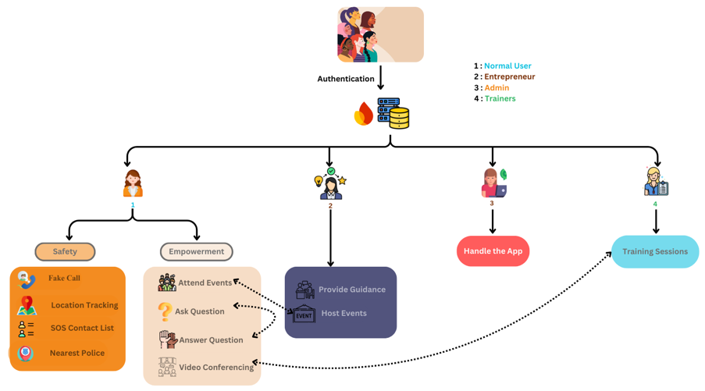

**Fig. 1.** System Design of Agati: A Role-Based Safety and Empowerment Architecture

**3.1 Safety & Empowerment Features**

Agati’s core mission is to ensure women’s safety in both online and offline environments through practical, real-time tools. The app features a Fake Call option that simulates an incoming call, allowing users to exit uncomfortable or dangerous situations discreetly. Live Location Tracking lets users share their real-time location with trusted SOS contacts, ensuring their safety during travel or emergencies. Additionally, Agati integrates Google Maps to fetch and display the nearest police station, enabling users to quickly find and navigate to law enforcement support. The SOS Contact List allows users to save emergency contacts, who receive instant alerts with the user’s live location and a preset message during critical moments. Together, these tools offer a strong safety net, boosting women's confidence and security.

Beyond safety, Agati focuses on empowering women by providing access to resources, communities, and opportunities. Through the Event Hosting and Booking Module, entrepreneurs can organize events and workshops, while users can browse and attend these events physically or virtually, fostering skill-building and networking. A

Machine Learning-based Recommendation Model suggests events tailored to users’ interests and activity history. Users can also book One-on-One Video Conferencing Sessions for personalized mentorship or training with professionals and entrepreneurs, supporting their individual growth.

The app includes an Open Discussion Forum where users can post questions, share insights, and engage in discussions on various topics, from safety tips to career guidance, helping build a strong community. To further simplify navigation, Agati features a Chatbot Assistant that helps users find events, schemes, and offers basic support for using the platform.

**3.2 Proposed Evaluation Metrics for Agati App Performance**

To ensure the Agati app delivers a high-quality, secure, and user-centric experience, the following evaluation metrics are proposed for implementation and assessment once the system is fully developed:

**Functional Performance Metrics**

Location Accuracy will ensure real-time tracking within 10–20 meters across various environments. SOS Response Time aims for alert dispatch within 3–5 seconds, and Fake Call Activation should trigger within 3 seconds. Recommendation Accuracy for event suggestions will be evaluated using precision, recall, and F1-score to maintain relevance and personalization.

**Performance Metrics**

App Launch Time will be optimized to under 3 seconds. API Response Time will stay below 500 milliseconds, and Database Query Execution will complete within 1 second for swift data access. Video Conferencing Latency will be kept under 300 milliseconds for smooth communication.

**User Experience (UX) Metrics**

The app targets a System Usability Scale (SUS) score above 80, a Crash-Free Rate of 99.99%, and Battery Consumption under 5% per 30 minutes of usage to ensure a stable and user-friendly experience.

**Scalability**

The app will be tested for Scalability and Load Handling, ensuring consistent performance and fast response times even during peak usage and as the user base grows.

**4 Results**

| **Fig. 2.** Login Page | **Fig. 3.** Home Page | **Fig. 4.** Safety Features |
| --- | --- | --- |
| **Fig. 5.** Events Page | **Fig. 6.** Open Forum | **Fig. 7.** Video Conferencing |

**5 Conclusion And Future Scope**

Agati’s empowerment module covers financial concepts such as budgeting, savings, digital payments (UPI, e-wallets), personal finance basics, entrepreneurship funding, and government assistance schemes. Content personalization is driven by onboarding preferences and user behavior, with an AI recommendation engine tailoring financial education. Effectiveness is measured through feedback surveys, engagement metrics, and knowledge quizzes to track user learning and impact.

For law enforcement collaboration, Agati will integrate secured APIs for consent-based SOS data sharing, supported by partnerships with safety agencies to enable faster response times. Blockchain-backed audit logs and user feedback on response quality will ensure transparency, trust, and accountability.

Future innovation includes AR-based self-defense training for realistic, accessible practice, hands-free SOS activation via wearables for discreet emergencies, and blockchain-secured data protection for enhanced privacy. Multilingual support and global rollout plans will broaden reach, while community-driven safety mapping will empower users with real-time risk insights.

Agati’s AR-based self-defense training will work on standard smartphones using built-in cameras and sensors, without needing any additional hardware. Enhanced experiences will be available on AR-compatible phones, but no external devices are required, ensuring accessibility for all users.

**References**

1. Y. Khandagale, G. More, I. Narvekar, M. Sharma, S. Sanap, “FearlessShe – Women Safety Mobile Application,” *International Journal of Advanced Research in Science, Communication and Technology*, 2025, DOI:<https://ijarsct.co.in/Paper23526.pdf>

2. S. Milkhe, D. Pomendkar, T. Rajabally, S. Ghane, “Technology100 - An Application for Women Safety,” *2020 IEEE International Conference on Technology, Engineering, Management for Societal Impact using Marketing, Entrepreneurship and Talent (TEMSMET)*, 2020, pp. 1-6, DOI: <https://ieeexplore.ieee.org/document/9557400>

3. J. S. Sree, R. B. Saranya, and S. R. Harikrishnan, "Protection From Domestic Violence," *International Journal of Advanced Research in Science, Communication and Technology*, 2024. DOI: 10.48175/ijarsct-19457.

4. A. Chinnasamy, A. Donde, D. Joshi, “Integrated Women’s Security System with Safe Route Navigation and Instant Law Enforcement Reporting,” 2024 4th International Conference on Pervasive Computing and Social Networking (ICPCSN), 2024, pp. 197-202, DOI: [10.1109/ICPCSN62568.2024.00041](https://ieeexplore.ieee.org/document/10411041).

5. M. Navale, “RescueNow: Real-time SOS and Predictive Women's Safety System,” International Journal of Scientific Research in Engineering and Management, 2024, DOI: 10.55041/ijsrem38086.

6. S.B.V, SHWETHASHRI K, “SafeSteps,” *International Journal of Scientific Research in Engineering and Management*, 2024, DOI: <https://ijsrem.com/download/safesteps/>

7. M. P, P. V. S, M. S, J. R, “Implementation of Building Stronger Communities for New Safety Approach and Recruitment using AIML,” 2024 International Conference on Emerging Research in Computational Science (ICERCS), 2024, pp. 1-5, DOI: 10.1109/ICERCS63125.2024.10895127.

8. J. Kaur, M. Gupta, P. Singh, “Understanding the Role of Technology-mediated Solutions for Women’s Safety in Urban India,” ACM SIGCAS/SIGCHI Conference on Computing and Sustainable Societies (COMPASS), 2022, DOI: 10.1145/3530190.3534843.

9. N. Vats, “Implementation of Smart 24x7 Women Security App W-SAFE,” International Journal for Research in Applied Science and Engineering Technology, 2024, DOI: 10.22214/ijraset.2024.62301.

10. A. K, S. N. Perla, “An Integrated Mobile Application for Enhancing Women’s Safety – A Comprehensive Approach,” 2024 IEEE International Conference for Women in Innovation, Technology & Entrepreneurship (ICWITE), 2024, pp. 223-228, DOI: 10.1109/ICWITE59797.2024.10503411.

11. U. Goradiya, N. Pandey, M. Khan, S. Tiwari, M. Pawar, “SAKHII- Empowering Women with One-Tap Safety App,” *International Journal of Scientific Research in Computer Science, Engineering and Information Technology*, 2024, DOI: <https://ijsrcseit.com/index.php/home/article/view/CSEIT2410254>

12. B. S. Patil, T. Jain, A. Gaikwad, S. Bhalekar, “Eviora: A Women’s Safety Application,” International Journal for Research in Applied Science and Engineering Technology, 2025, DOI: 10.22214/ijraset.2025.66608.

13. S. Sharma and P. Ranjana, “Women Safety-Saviour Android Application,” 2022 2nd International Conference on Advance Computing and Innovative Technologies in Engineering (ICACITE), 2022, pp. 1552-1556, DOI: 10.1109/icacite53722.2022.9823496.

14. S. Lokhande, D. Nikalje, D. Sawant, P. Jadhav, and V. Gaikwad, “Women Safety Using Android,” *International Journal of Advanced Research in Science, Communication and Technology*, 2024, DOI: 10.48175/ijarsct-15543.

15. C. J. Philip, G. Hedvikar, K. Rawal, T. Naidu, and B. Roy, “EmpowerHer - A Guardian Wristband for Women Safety with Mobile Application,” *2023 6th International Conference on Advances in Science and Technology (ICAST)*, 2023, pp. 335-340, DOI: 10.1109/ICAST59062.2023.10454916.

16. S. Dubey, “WOMEN SAFETY APP,” *International Journal of Scientific Research in Engineering and Management*, 2024, DOI: 10.55041/ijsrem35410.

17. T. Tathe, H. Wadne, P. Patil, and D. Waydande, “SafeSteps: A Flutter-Based Application to Provide Security to Women,” *International Journal of Scientific Research in Engineering and Management*, 2024, DOI: 10.55041/ijsrem38622.

18. Md Arfanul Haque, Md Ashikur Rahman, Rubayea Ferdows, and Fuad Ahmed, “Design and Implementation of a GPS-GSM Based Women Safety Device for Combating Sexual Assaults,” *2023 5th International Conference on Sustainable Technologies for Industry 5.0 (STI)*, pp. 1-5, 2023, DOI: 10.1109/STI59863.2023.10465174.

19. S. Vahini, “Efficient Tracking for Women Safety and Security Using IoT,” *International Journal of Advanced Research in Computer Science*, vol. 8, pp. 328-330, 2017, DOI: 10.26483/IJARCS.V8I9.4915.

20. Riddhi Vasant Hadkar, Apratim Pravin Phadke, Harsh Satpute, Kranti Raut, and Pallavi Deshpande, “An Efficient IoT-Enabled Women Safety Device,” *2024 3rd International Conference on Automation, Computing and Renewable Systems (ICACRS)*, pp. 425-431, 2024, DOI: 10.1109/ICACRS62842.2024.10841797.

21. Sandesh Walunj, Akshay Gupta, Puja Gholap, Anuradha Sonone, and Saurabh Yadav, “WS-APP Women's Safety System Based on Android Application,” *International Journal of Advanced Research in Science, Communication and Technology*, 2022, DOI: 10.48175/ijarsct-7562.

22. M. Dhore, Himanshu Bhatia, Shraddha Bagav, Prajwal Kadam, and Amey Dhuri, “Smart Shoes for Women Safety with Implicit Triggers,” *2023 World Conference on Communication & Computing (WCONF)*, 2023, pp. 1-6, DOI: 10.1109/WCONF58270.2023.10235229.

23. Boomika A, Divyapriya E, Vanathi K, Vidhya N, Parameswaran Ramesh, and B. V, “Empowering Women Safety: A GPS-Enabled IoT Tracking System,” *2024 International Conference on Emerging Trends in Networks and Computer Communications (ETNCC)*, 2024, pp. 1-6, DOI: 10.1109/ETNCC63262.2024.10767557.

24. Barukam Vamshikrishna Yadav, A. Viji Amutha Mary, Mercy Paul Selvan, S. Jancy, and L. Helen, “Arduino based Women Safety Tracker Device,” *2023 7th International Conference on Trends in Electronics and Informatics (ICOEI)*, 2023, pp. 433-436, DOI: 10.1109/ICOEI56765.2023.10126053.

25. S. Yadav, Kavita Sharma, and Ananya Gupta, “SafeWomen: A Smart Device to Secure Women's Environment Using ATmega328 With an Android Tracking App,” *International Journal of Digital Crime and Forensics*, vol. 13, 2021, pp. 48-64, DOI: 10.4018/ijdcf.2021010103.

26. C. S. Suttur, P. V, R. R, Rapaka Rakshith, S. N, and Supriya S. Mangalgi, “Women Safety System,” *2022 4th International Conference on Circuits, Control, Communication and Computing (I4C)*, 2022, pp. 416-420, DOI: 10.1109/I4C57141.2022.10057852.

27. S. Alateeg and S. Al-Ayed, "Exploring the role of artificial intelligence technology in empowering women-led startups," *Knowledge and Performance Management*, 2024. DOI: 10.21511/kpm.08(2).2024.03.

28. R. Naaz, R. Sharma, B. R. Soni, S. Agarwal, and R. Tiwari, "Prediction of Women Entrepreneurial Intention Through Educational Support using Machine Learning Algorithms," *2024 Second International Conference on Advanced Computing & Communication Technologies (ICACCTech)*, 2024, pp. 700-705. DOI: 10.1109/ICACCTech65084.2024.00117.

29. S. Hazudin, M. Sabri, M. A. R. A. Kader, and M. Ishak, "Empowering Women-owned Businesses in the Era of Digital Transformation: A Review of the Opportunities and Challenges," *International Journal of Academic Research in Business and Social Sciences*, vol. 11, no. 19, 2021. DOI: 10.6007/ijarbss/v11-i19/11731.

30. A. Fauzia and S. Hidayati, "Improving Digital Literacy of Rural Women Entrepreneurs in Indonesia," in *2023 11th International Conference on Cyber and IT Service Management (CITSM)*, 2023, pp. 1–5. DOI: 10.1109/CITSM60085.2023.10455473.

31. I’m Safe App on play store - Link:<https://play.google.com/store/search?q=i%20am%20safe&c=apps&hl=en-IN>.

32. Abhivyakti App on play store - Link:<https://play.google.com/store/apps/details?id=com.wes.abhivyakti&hl=en-IN>.

33. Women Entrepreneurs Central IL App on play store - Link:<https://play.google.com/store/apps/details?id=com.clubexpress.WeCiOrg&hl=en&gl=US>.

**Acceptance Letter**

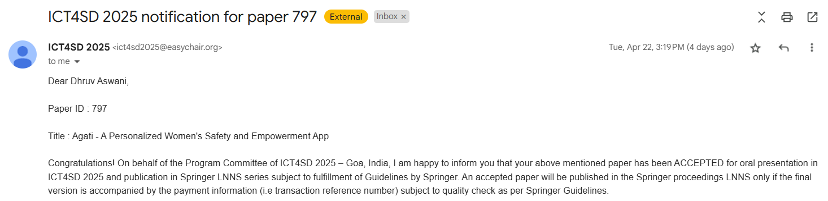

**Plagiarism Report**

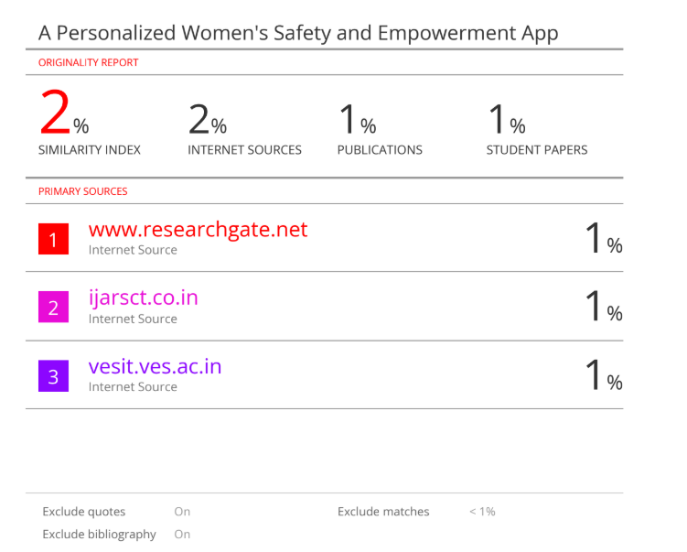

**Review 1 Sheet**

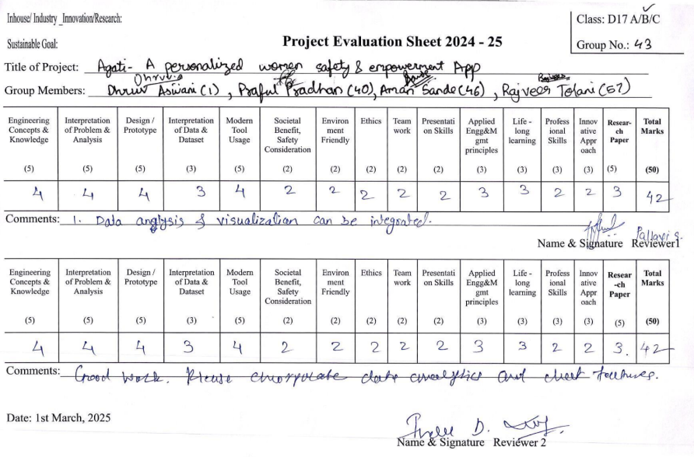

**Review 2 Sheet**

